


FINAL REPORT
Consultancy Services
Competency and training needs assessment of primary health care facilities and municipality hospitals in Albania

June 30, 2023
Samerberg, Germany


Table of Content

List of Abbreviations 3
1. Context and approach 5
1.1 European standards in Emergency Medicine: EUSEM 5
1.1.1 EBEEM and EMERGE 6
1.1.2 Status of European Postgraduate Medical Assessments 7
1.2 European standards in EM for nurses: EuSEN 8
1.3 Response indicators for pre hospital care 9
1.4 Ambulance transportation 10
Non-emergency levels 10
Emergency transportation 11
Non-emergency transportation 11
2. Methodologies for assessing competencies and training needs 13
3. Primary data collection 16
3.1 Interviews 16
3.2 Online questionnaire 17
3.3 Data Analysis 17
4. Description of the status quo in EM provision at the PHC level and municipal hospitals in Albania 19
4.1 Existing standards, guidelines, and frameworks for core competencies 19
4.1.1 Administrative and territorial health system reforms 20
4.1.2 Roles and functions of different stakeholders 23
4.2 Assessment of emergency medical care competencies 23
4.2.1 Institutions offering academic programs and professional training 24
4.2.2 Actual education and professional training of EM staff 25
4.2.3 Developed EM skills and competencies 27
4.2.4 Curricula and ongoing education for EM personnel 27
4.2.5 EM skills and competencies needed to license as medical practitioner 27
4.2.6 EM skills and competencies in regulatory documents and job descriptions 28
4.2.7 Support to health practitioners for performing and practicing EM care 28
4.2.8 Availability and use of emergency care drugs 28
4.2.9 Credit requirements in CME system 29
4.3 Assessment of emergency medical care training needs 29
4.3.1 Training needs of EM staff 29
4.3.2 Hosting and ownership of institutional opportunities 30
4.3.3 Training and knowledge building of professional and non-professional in emergency response and health care 31
4.3.4 Curricula for Training the Trainers 31
4.3.5 Knowledge building for emergencies and emergency health care 31
4.3.6 Model for regional training centers for emergency preparedness & response 31
4.3.7 Public health DRR discussion platforms for local level volunteers and emergency responders 32
4.3.8 Small-scale exercise plans for communities in emergencies 32
4.3.9 Involvement of private sector in emergency preparedness and response 32
4.3.10 Gender approach and involvement of vulnerable population 34
4.3.11 Strategies, plans, and synergies for training centers 34
4.4 Results of questionnaire 35
4.4.1 Nurses’ answers 35
4.4.2 Physicians’ answers 37
5. Gap analysis and ranking of competencies and training needs 39
5.1 Gap analysis 39
5.1.1 Gap analysis of competencies 39
5.1.2 Gap analysis of training needs 43
5.2 Ranking of gaps 45
5.2.1 Highest-ranked competency gaps 45
5.2.2 Highest-ranked training needs gaps 45
6. Recommendations for competency and training building at PHC and municipal hospital level in Albania 47
6.1 Recommendations for building competency 47
6.2 Recommendations for improving trainings 50
Literature 56
ANNEX 1: Table of interviewees 57
ANNEX 2: Online Questionnaire 60
ANNEX 3: EuSEN Emergency Department Nurse Competencies 65
ANNEX 4: Figures of questionnaire’s results 68

List of Abbreviations
ACA Albanian Community Assist
ACLS Advanced Cardiovascular Life Support
AED Automated external defibrillator
ALS Advanced Life Support
ARC Albanian Red Cross
ATLS Advanced Trauma Life Support
BLS Basic Life Support
CHF Chronic Heart Failure
CME Continued Medical Education
CNE Continued Nursing Education
CPR Cardiopulmonary Resuscitation
CSTE Council of State and Territorial Epidemiologists
DRA Disaster Risk Assessment
DRR Disaster Risk Reduction
EBEEM European Board Examination in Emergency Medicine
ECDC European Centre for Disease Prevention and Control
ED Emergency Department
EFPA European Federation of Psychologists Association
EHC Emergency Health Care
EM Emergency Medicine
EMC Emergency Medical Care
EMS Emergency Medical Services
EN Emergency Nursing
EPHC Emergency Public Health Centre
ERA Emergency Response Albania.
EU European Union
EUSEM European Society for Emergency Medicine
EuSEN European Society for Emergency Nursing
FF Fire Fighters
GfA Society for Agricultural Projects
GP General Practitioner
HAP Health for All Project
HC Health Care Centre
HR High Risk
ICU Intensive Care Unit
IDC Infectious Diseases Clinic
IPH Institute of Public Health
ISHPSHS State Inspectorate of Labor and Social Services
ISHSH State Health Inspectorate of Albania
LHCU Local Health Care Units (administrative body of care)
MCE Mass Casualty Event
MoHSP Ministry of Health and Social Protection
NCA National Competent Authority
NCE/ QKUM National Centre for Emergency
NCCE/ QKEV National Centre for Continuing Education
NCPA/ AKMC National Civil Protection Agency
NDRRS National Disaster Risk Reduction Strategy
NEC/ CSEM National Emergency Medical Centre
NGO Non-Governmental Organization
OBG Obstetrics and Gynecology
OTC Over-the-Counter Drugs
PALS Pediatric Advanced Life Support
PBLS Pediatric Basic Life Support
PF Police Forces
PCR Polymerase Chain Reaction
PHC Primary Health Care
PHEP Public Health Emergency Preparedness
PPE Personal Protective Equipment
PTSD Post Traumatic Stress Disorder
RN Registered Nurses
SDC Swiss Agency for Development and Cooperation
SOP Standard Operating Procedure
TFL Together! For Life!
ToR Term of References
ToT Training of Trainers
UEMS European Union of Medical Specialists
UEMS-CESMA European Union of Medical Specialists - The Council for European Medical Specialist Assessments
UNDP United Nations Development Programme
UNFPA United Nations Population Fund
UNICEF United Nations International Children's Emergency Fund
USAR Urban search-and-rescue
WASH Water, Sanitation, and Hygiene
WHO World Health Organization

Context and approach
As of February 1, 2023, Gesellschaft für Agrarprojekte (GfA) Consulting Group has started the implementation of a Swiss Agency for Development and Cooperation (SDC) project: “Support to health emergency service preparedness and response in Albania”.
The overarching goal of the project is to ensure that people, including the most vulnerable, have improved access to quality emergency care services managed by a more resilient health emergency system at all levels.
This project intends to improve the country’s resilience to public health emergencies by engaging public health actors to engage more effectively and efficiently in health emergency preparedness and response, including 24/7 Primary Health Care (PHC) and Municipality Hospitals, strengthening emergency medical services, and empowering citizens and civil society organizations for a participatory approach in health emergency response.
Subcontracted by Society for Agricultural Projects (GfA) Consulting Group and based on the Terms of Reference (ToR), Prepared International (PPI) in this report presents the following:
- The assessment methodologies for capacities and training needs.
- Administrative roles and functions of the involved stakeholders in establishing changing and upgrading of competencies of PHC’s staff and staff of Municipality Hospitals
- Analysis of the Albanian context: past and current territorial and health reform, the current situation of Emergency Medical Care (EMC) reform, and future directions, roles, and functions of various stakeholders
The final report provides comprehensive information about frameworks for assessing competencies and training needs in health emergencies and emergency medical care in contexts similar to Albania, a detailed description of actual competencies and training needs identified as well as concrete recommendations for effective competency and training building approaches, models and instruments in accordance with the existing structures, capacities, and resources. (ToR 3.8)

1.1 European standards in Emergency Medicine: EUSEM
Europe encompasses not only different languages and cultures, but also a similar number of different systems of health care and medical practice. Each country has different medical traditions, different systems of professional registration and differing lists of medical specialties. This latter problem has been addressed in part by the European Union and, in particular, by the Department or Directorate-General which deals with the Internal Market and which includes the mutual recognition of diplomas and other free movement issues. The relevant EU Directive for medical qualifications is known as the ‘Doctors’ Directive’ and was first issued as 1993/16/EC, but most recently updated as 2005/36/EC (January 2019).
The Directive requires that the period of training for Emergency Medicine (EM) should be a minimum of five years and many EU countries have now recognized Emergency Medicine as a primary specialty with these training requirements. Emergency Medicine also exists in several countries as a supra-specialty. Annex V to Directive 2005/36/EC included 16 countries with the specially of Emergency Medicine, with a minimum of 5 years program. Several of the remaining EU countries are making significant progress towards recognition of the EM specialty, but it can be a slow and arduous journey! Nonetheless, there has been a very significant increase in the recognition of Emergency Medicine as a primary specialty in Europe during the last decade and this is in line with the rest of the world where there is similar growth in recognition of the specialty.
The European Society for Emergency Medicine (EUSEM) is a non-profit scientific organization whose aim is to promote and foster the concept, philosophy, and art of EM throughout Europe. The ultimate objective of the Society is to help and support European nations to achieve the specialty of EM. It began as a society of individuals in 1994 from a multidisciplinary group of experts in EM, and in 2005 EUSEM incorporated thirty-four European national societies of EM as members. The EM medicine program is about four years old, where about 70% of the program covers theory and 30% is practical.

1.1.1 EBEEM and EMERGE
The European Board Examination in Emergency Medicine (EBEEM) is developed and implemented by the Emergency Medicine Examination Reference Group in Europe (EMERGE).
EMERGE is a joint committee of EUSEM and the European Union of Medical Specialists (UEMS) Section of EM. It is a two-part examination designed to confirm the candidate’s suitability for independent practice as an Emergency Physician within any country in the EU. The examination assesses the knowledge, skills, and behaviors necessary for the clinical practice of Emergency Services at the level of the specialist or consultant engaged in independent practice. This confirms that the successful candidate can provide clinical leadership in the Emergency Department (ED).
The European Board Exam has been running for many years now and has an increasing number of applications from a global range of countries, including many European countries. However, there remain some concerns about the purpose of the Board Exam and for some people uncertainty about the legal standing of the EBEEM.

There are clear advantages to the individual of success in the EBEEM;
- Institutions may elect to require success in the EBEEM for specialist/ consultant appointments.
- Institutions may utilize success in the EBEEM to differentiate between two applicants for the same post
- Training authorities may use the EBEEM (preparation and success) as part of the criteria for the accreditation process of training sites
- Individual departments may use success as a marker for promotion, e.g., for the successful candidate to be promoted to head of the department
- Countries without an existing formal exit exam may choose to use the EBEEM as their final exam for the completion of training
- Success in Part A can be used as an in-training evaluation to assess the progress of trainees in a training program
- Training programs may use success in the EBEEM to validate their training program.
This is a European exam with a focus on European candidates. To ensure that the focus is maintained on Europe we encourage as many European trainees as possible to participate.

1.1.2 Status of European Postgraduate Medical Assessments
Regarding the legal standing of these postgraduate medical exams, the "UEMS-CESMA” Guideline for the organizations of European postgraduate medical assessments" states:
- European postgraduate medical assessments are to be considered as a quality mark unless otherwise recognized by a National Competent Authority e(NCA). Unless full NCA recognition has been obtained, the European postgraduate medical assessments will be considered complementary to the national examination.
- European postgraduate medical assessments will facilitate the mobility of medical practitioners throughout the EU by assessing specialist knowledge at an agreed EU standard. Furthermore, the European examinations will enable benchmarking of candidates against their European colleagues in other EU countries.
- However, passing a European postgraduate medical assessment will not imply a license to practice. Is only the NCA that will be able to provide such a license. Nevertheless, where full NCA recognition of a qualification applies, the European postgraduate medical assessments may provide a means for the NCA to determine eligibility for a license to practice.
This statement is written by the members of EMERGE and designed to help Emergency Physicians in Europe understand the importance and value of taking this specialist exam in EM This is particularly relevant for countries where there is currently no exit exam at the end of training.
Success in the EBEEM does not confer a legal right to work as either a non-specialist (general medical registration) or specialist in any of the European countries (as you can see in the UEMS-CESMA guidelines). This is still dependent on the requirements of the national competent authorities.
The EMS systems in each country have many features in common but there is no standard European system to compare them. The systems are delivered by a variety of providers and funded with different funding mechanisms. Organization and logistics, particularly of dispatch, triage and prioritization, are critically important and further development is necessary to achieve a standardized approach to EMS in the expanded EU and respect to third countries. The variation and diversity of system designs is the main obstacle to coordinating EMS systems. Comparative studies usually focus on one specific aspect of the system, such as staffing, costs or clinical outcomes. The existence of a common set of Certifications of Quality for all EMS Service in Europe could be a solid instrument to make the communication and coordination among different countries and regions easier to achieve.

1.2 European standards in EM for nurses: EuSEN
The European Society for Emergency Nursing (EuSEN) promotes the art and science of emergency nursing across Europe and provides a platform for knowledge and information sharing amongst its members in the interest of our patients of today the one hand in Albania, nursing professionalization is promoted the high level (Academic degrees) but on the other hand, there is not much between the knowledge learned and the performance in the field. The EuSEN Emergency Department Nurse Competencies focus on Clinical skills, Communication skills, Teamwork/collaboration, Knowledge and scope of practice, Professional development, Organizational Awareness, Research, and Quality improvement
The majority of the studies in Albania are theoretical, with very limited practical experience. Moreover, when a nursing student arrives in the clinical field, they do not have well-organized tutoring; therefore, they do not find the existing potential of nursing competencies.
Example: Nurses in PHC operated the ECG machine, but they did not interpret it due to a lack of knowledge and lack of authorization for interpretation. Performing ECG on a technical level without understanding the ECG chart prevents nursing empowerment. There is a need to train nurses to become case managers and not technicians. This requires understanding the analytical findings, interpreting, making a decision concerning alternatives, intervening, and evaluating the outcome.
To empower the nurses, there is a need to establish role definitions of nurses' work in different departments, as well as legislation of the nurses' roles and activities. This is currently lagging.

1.3 Response indicators for pre hospital care
Accepted response indicators are important to evaluate the function of a medical response system. Without quantified targets, the system can not be evaluated on its performance. If for instance a response time for an ambulance arriving on the scene of an emergency is set at 20 minutes maximum, a strategic distribution of prehospital care with ambulance and or helicopters requires to be established. When time before pain treatment on location of emergency, time before AED can be applied on location are defined as PHC indicators, also the capacities and qualifications and thus training requirements for first responders are required to be set, achieved and evaluated.
In this paragraph indicators of various EU countries are presented. This reference aims to support dialogue in Albania to define SMART emergency indicators to be achieved over time. These SMART indicators can function of drivers for system change.
In Europe there is an ongoing process to establish response indicators for Emergency medical services. For now these are not standardized. Differences between countries occur as a result of political and policy traditions, development status, level of urbanization (highly populated areas tend to have shorter response times as the investments will serve a larger population than in rural areas that have lower economy of scale), road accessibility, geographical considerations, weather conditions etcetera.
Ambulance services in Europe are financed on the basis of public money, most of the time through health insurances (Belgium; Croatia; Czech Republic; Germany; Ireland; Lithuania; the Netherlands; Turkey; UK), and sometimes through public donations (Belgium and Ireland). Further, ambulance services in Belgium, Germany, and Turkey make use of private funding as well. The total budget (2014) of countries for ambulance services varies between 25 million (Belgium) and 5 billion (Norway). Some budgets are exclusively allocated to the organization of ambulance care in emergency situations whilst other budgets are allocated for ambulance care in case of emergency and non-emergency ambulance transport.

Table: Variations in National financial budget for ambulance care
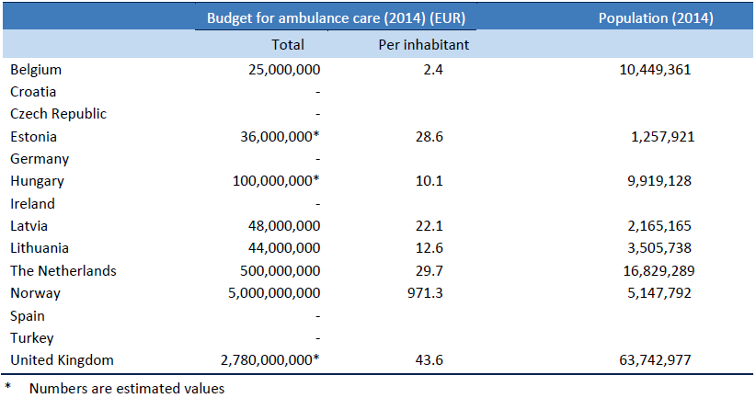

1.4 Ambulance transportation
In EU countries a difference is made between emergency and non-emergency transportation services, except for Croatia and the Netherlands. For some countries emergency and non-emergency services are provided by different organizations, e.g. in Belgium the emergency service is organized at a federal level, whereas non-emergency transportations are organized at a regional level. Non-emergency services may also be delivered by private organizations, such as in Czech Republic, or by commercial providers, as is the case in Hungary and the UK.
In all countries distinctions are being made between levels of emergency, except for Croatia. In Ireland and the UK five levels of emergency status are being recognized. In Estonia and Latvia four levels are distinguished. In Belgium, Czech Republic, Germany, Hungary, Lithuania, Norway, Spain, and Turkey, there are three levels of emergency for transportation. In the Netherlands two levels of emergency for transportation are used. Emergency levels and response times are presented in the table on page 12.

Non-emergency levels
In most of the countries there are different levels for non-emergency ambulance transportations. In Germany, Hungary and the Netherlands, a difference is made between intensive/high care unit (ICU) transportations and other transportations. Further, Germany distinguishes between long and shorter distance transportations. In Ireland there are different levels for transportation of patients in need of critical care during transportation, subcategorized in adults, neonates and children. In addition, there is a separate category for inter-facilities transportations. The latter category was also found in the Czech Republic and Latvia. In Spain non-emergency ambulance transportations are categorized as individual or collective transportations.

Emergency transportation
Response times were given for Czech Republic, Estonia, Germany, Hungary, Ireland, Latvia, Lithuania, the Netherlands, Norway, Spain, Turkey, and the UK (table 3.5). In case of life threatening situations, response time in most countries is 15 minutes or less, except for the Czech Republic with a response time of 20 minutes. In Latvia arrival time is set between 8-10 minutes. In Ireland in case of cardiac arrest, respiratory arrest or other life threatening situations this is 8 minutes, in all other cases of serious but not life-threatening events this is 19 minutes. In Estonia, response times for urgent care (potentially life-threatening) is 20 minutes at most. For non-critical care the response time is 30 minutes, which is the same for the Netherlands in case of non-life threatening events.

Non-emergency transportation
In case off less urgent or inter-hospital transportations, arrival times differ between countries ranging from 60 minutes to four hours.

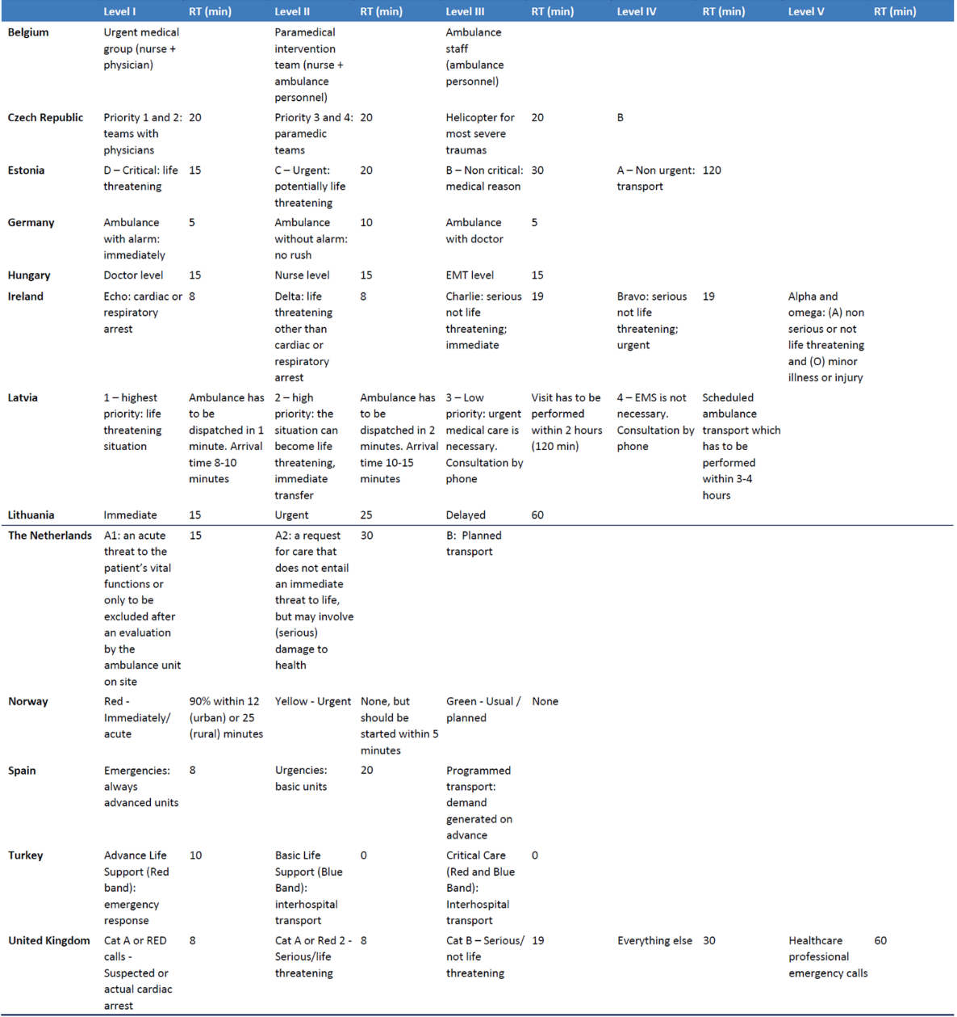
Table: Emergency levels and response times in 12 European countries

Methodologies for assessing competencies and training needs
The combined methodology presented here was designed to assess the emergency medical care competencies and training needs on primary and secondary health care level. (ToR 3.2, 3.3)
Our methodology used the European Centre for Disease Prevention and Control (ECDC)’s “Public health emergency preparedness – Core Competencies for EU Member States” (2017) as a reference for the foundational topics for the interviews to identify strengths and weaknesses in the medical first response system. We would like to note that the scope of the work does not allow for a full evaluation of all attributes; instead, we aimed to evaluate the knowledge and skills attributes qualitatively based on observations during the interviews and the self-assessment questionnaire to define capacity and training needs. Additionally, we examined other assessment methodologies to strengthen our primary data collection.
The ECDC’s “Public health emergency preparedness” (PHEP) – Core Competencies for EU Member States”, describes a public health emergency preparedness logic model to “identify both the strengths and the areas for improvement of the PHEP in the European Union Member States” (ECDC, 2017).
In its definition, it describes capabilities as, “what Member States are expected to achieve during an emergency, and can be described in a consistent way for all countries” (ECDC, 2017).
ECDC defines 5 capabilities, along with several indicators per category (Table 1).
Capabilities are described in terms of competencies; that is, the “combinations of knowledge and skills that are required to perform a task effectively” (ECDC, 2017). Knowledge is defined as “the outcome of the assimilation of information through learning”, while skills are “the ability to apply knowledge and use know-how to complete tasks and solve problems” (ECDC, 2017). That is: By measuring both knowledge and skills as attributes, we can evaluate single competencies and, therefore, the overall capability of the PHEP. Based on these definitions, ECDC considers competency-based education and training.

Table 1. Response capabilities (source: ECDC, 2017)
Capability | Indicator
1. Detection and assessment | 1.1 Incident recognition  1.2 Risk characterization  1.3 Epidemiological investigations  1.4 Surveillance and epidemiological monitoring  1.5 Laboratory analysis  1.6 Environmental monitoring
2. Policy development, adaptation, and implementation | 2.1 For infection control and treatment guidance  2.2 For population-based disease control  2.3 Communicating between national and subnational authorities and enforcing laws and regulations
3. Health services | 3.1 Preventive services  3.2 Medical surges  3.3 Management of medical countermeasures, supplies, and equipment  3.4 Medical services for healthcare workers and emergency responders
4. Coordination and communication (within the public health emergency preparedness system) | 4.1 Crisis management  4.2 Communication with healthcare providers  4.3 Communication with emergency management, public safety, and other sectors  4.4 Communication with other public health agencies at the global, European, national, and subnational level
5. Emergency risk communication (with the public) | 5.1 Address communication inequalities  5.2 Use dynamic listening and manage rumors  5.3 Communicate risk in an accurate, transparent, and timely manner  5.4 Foster and maintain trust
Here we present the additional assessment methodologies evaluated and the topics included in the applied tailored methodology;
- We included central aspects from World Health Organization (WHO)’s “Toolkit for assessing health-system capacity for crisis management” (2012)- in particular, its “Section 2: Health Workforce”- to assess whether training and their curriculum are competency-based, harmonized, measurable and whether they include exercise and drills, along with their frequency and resource allocation.
In the case of Albania, we consider it essential to define competencies according to professional roles and to provide both adequate training and the proper legal framework that protects clinical personnel. We pinpointed the need for harmonized training, enough resource allocation, and a central database of trained emergency staff.
- WHO’s “Field Manual for Capacity Assessment of Health Facilities in Responding to Emergencies” (2007) goes into further detail in terms of institutional and financial support, as well as regular exercises.
- The United Nations Development Programme (UNDP)’s “Measuring Capacity” (2010) addresses capacity development through educational reforms for professional learning and Public-Private Partnerships (PPP). In these aspects, we have included the relevance of the collaboration between the public, private, and civil sectors in the strategic plan and cross-sectional training, and PPP.
- WHO’s “Hospital emergency response checklist” (2011) considers additional staff and volunteers, as well as specific training for areas with increased clinical demand, including emergency and intensive care.
- ECDC’s “A literature review of Training Needs Assessment (TRNA) methodology” (2017), together with the Council of State and Territorial Epidemiologists (CSTE)’s “Epidemiology Capacity Assessment” (2017) methodology to identify the main question to assess formal training, continuing education, and perceived training needs in emergency health care, along with the identification of the structures that lead to clinical personnel undertaking activities outside of their professional role’s competencies. The goal of this evaluation is to improve the capability of the PHC network to deal with emergency and urgent cases through specialized training.
By strengthening the ECDC’s framework with indicators and questions from other assessment methodologies, we were able to obtain a national profile of EMS capacities and training needs.

Primary data collection
Primary data collection was done utilizing:
- in-depth interviews with key informants and primary and secondary HC level staff carried out on the field.
- an online questionnaire for doctors, nurses, and PHC administrative directors.

3.1 Interviews
In-depth interviews were carried out with selected key informants concerning the competencies and training needs of HC staff working at the primary and secondary HC levels in Albania. (ToR 3.6)
The interview questions were foremost about training priorities according to the five capabilities described in the methodology and as seen by the various target groups; therefore, these questions allowed all invited professionals to contribute to training priority setting.
Additionally, most interviews were conducted on-site, which allowed us to visit and examine first-hand the conditions in municipal and regional hospitals, PHC, Emergency Units, ED, and research laboratories.
The complete list of interviewees can be found in ANNEX 1. In brief, we interviewed people from the following healthcare institutions and facilities:
- Hospitals: Kavaja Municipal Hospital (Spitali Kavajë), Mother Teresa University Hospital Center.
- PHC: Kamez Health Center (Qendra Shëndetësore Kamëz), Vora Health Center (Qendra Shëndetësore Vorë)
- Professional orders: Order of Nurses of Albania, Order of Physicians of Albania, Order of Psychologists of Albania
- Government institutions: National Civil Protection Agency (NCPA/ AKMC), Regional Operator of Healthcare Services of Tirana, State Inspectorate of Labor and Social Services (ISHPSHS), State Health Inspectorate of Albania (ISHSH)
- Universities: University of Medicine Tirana: Faculty of Medicine, Faculty of Technical Medical Sciences.
- International organization and donors: Embassy of Switzerland in Albania, Swiss Agency for Development and Cooperation (SDC)-funded Health for All Project (HAP), United Nations International Children's Emergency Fund (UNICEF), United Nations Population Fund (UNFPA)
- National auxiliary organizations: Red Cross Albania
- Civil society organizations: Albanian Community Assist (ACA), Together! For Life! (TfL)
We could not meet with the representatives from the following institutions and organizations: Ministry of Health and Social Protection (MoHSP), World Health Organization (WHO), Institute of Public Health (IPH/ISHP), National Center for Continuing Education (NCCE/QKEV), National Medical Emergency Center (NEMC /CSEM), United Nations Population Fund (UNFPA), and Emergency Response Albania (ERA).

3.2 Online questionnaire
The questionnaire aims to facilitate the bottom-up participation of the following medical and administrative staff: General practitioners, Specialist Doctors, the hospital’s Chief Nurses, the department’s Head Nurses, Staff Nurses, the hospital’s Directors, and the department’s Directors.
In the questionnaire, we aim to measure:
- Familiarity with procedures.
- Knowledge of emergency plans.
- Control of infectious diseases.
- Facility capacities.
- Training offer and frequency.
- Participation in drills/exercises.
- Qualification/skills in emergency procedures.
- Confidence in performing medical activities.
- Identification of 3 training topics to prioritize.
- Practical skill sets nurses to identify as necessary.
The link to the questionnaire is the following: https://forms.gle/gPJPv34hz8ZHaH4VA, while the questions of the online questionnaire may be found in ANNEX 2.

3.3 Data Analysis
Results of the online questionnaire, interviews, and visits were gathered and analyzed for insight. We evaluated competencies and training needs (including structures that create an enabling environment for joint training, exercises, and drills), according to knowledge and skill measurements and the identified gaps.
This analysis worked as the background to come up with concrete recommendations for the implementation part of this project. Ranking is based on the potential to solve a performance problem by training, cost, and time. While the final ranking of priorities for implementation will have to be done in cooperation with SDC and GfA, as well as key Albanian stakeholders, we provide a recommendation for this ranking by considering the following points:
- Addressing crucial knowledge gaps within the first year to build a foundation for the successful overall implementation
- Priorities identified by the PHC staff in the online questionnaire
- Critical gaps identified during the interviews and on-site visits
- Key points needed to be addressed to close the gap between EU minimum standards and the current situation in Albania
- Achievement of an equal standard across the country for everyone including for vulnerable groups
- Considerations of gender-awareness
- Preparedness for large-scale emergencies including mass casualty incidents
- Evaluation of nurses’ skills to deal with everyday work practice and emergency situations.

Description of the status quo in EM provision at the PHC level and municipal hospitals in Albania
Detailed description of actual competencies and training needs identified. (ToR 3.8)
The following analysis and conclusions of the actual competencies and training needs related in emergency medical services at PHC facilities and municipal hospitals are based on the interviews with different stakeholders and the online questionnaire. The chapter start with an overview of legislative frameworks and policy goals.

4.1 Existing standards, guidelines, and frameworks for core competencies
Based on Law no. 10107, dated 30.03.2009, “On health care in the Republic of Albania”, Article 4 “state responsibilities” the Ministry of Health and Social Protection prepares the strategy of the health care system which includes relevant policies and programs. The General Directorate of Policies and Development of Health and Social Protection, at MoHSP, is responsible for drafting policies and programs related to health care and social protection in the Republic of Albania. Other institutions of health care and social protection in inter-institutional interaction at central and local levels, cooperate with the relevant ministry covering health and social protection issues to draft policies and exchange adequate information regarding the implementation and ensuring of health care for the Albanian population.
The unification of the two sectors, those of healthcare and social protection, under one umbrella, since 2017, has facilitated the work towards a vision of integrated healthcare that meets the needs of the citizens and addresses issues related to the well-being of a society at the core. The healthcare programme is based and relies on four pillars:
- Early prevention and diagnosis of non-communicable diseases through the creation and implementation of preventive programs, responding to demographic developments, new epidemiological profiles, increased life expectancy and reduced risk factors in the population.
- Transformation and improvement of primary care by strengthening the role of the family doctor and that of the nurse, as well as including, alongside the basic components of the service, new socio-health services for citizens such as home care, mental healthcare, psychologist/social worker service and strengthening of the preventive programs in primary care for communicable and non-communicable diseases.
- Strengthening and modernization of hospital care service including the concepts of hospital autonomy, costing of services, optimization of human and financial resources in order to create a model of hospital care that best integrates and translates health interventions into specialized care for citizens public and primary care.
- Modernization of services and consolidation of the digital infrastructure, which is another important instrument to fight corruption and to rapidly increase the quality of services for the public, while efforts will be intensified to build the Integrated Health Platform that expands the electronic healthcare systems, response systems to epidemics, tele-consultations, for more efficiency in the healthcare system by reducing geographical and financial barriers for the beneficiaries.

4.1.1 Administrative and territorial health system reforms
- Law No. 115/2014 “On Administrative-Territorial Division of the Local Government Units in the Republic of Albania”
This Law implemented in 2014 introduced a new structure. As a result the number of local governmental units was reduced from 373 units (municipalities and communes) to the current 61 municipalities and the ministries of Health and the ministry of Social protection merged into one ministry. Also the national Operator was introduced, strengthening the coordination in the healthcare sector. The decentralization laws protect local governments’ autonomy, competences, and resources through a subsidiarity principle. Local governments share responsibility with the national government in terms of health care, social services, and education, but are responsible for their own infrastructure, water supply, sewage, cleaning, and waste management.
- Framework legislation 147/2014 (“On Medical Emergency Service”)
Through a governmental decree, the National Center for Medical Emergency (NCME/ QKUM) was created to train medical personnel, select by phone no 127 the best emergency intervention, coordination of health care centers, guarantee an appropriate ambulance service distribution, inform the public during emergencies, and to maintain the National Registry for Emergencies (QKUM, 2017).
- Operator of Health Care Services
The country is subjected to significant structural reforms: the merging of health and social policy-making institutions at the national level, an institutional reform that has led to the creation of new institutions, such as the National Health Care Operator with its 4 regional directorates which are undertaking a series of functions in health care planning and administration in the primary and secondary health care services field. These developments have followed a broad territorial reform integrating small communities into larger municipalities as well as performing a decentralization process that aims to enhance power and accountability at the local government level.
- Creation of Local Health Care Units (LHCUs)
The mission of PHC is to focus on community health and not only on individual health. An important part of the services provided in PHC facilities should aim at disease prevention and health promotion. Many public health programs, for the control of both communicable and chronic diseases (vaccination, education, surveillance, screening), can reach communities only through PHC services. The efficiency of the relationship between the new local health care units and the health centers will be further improved in the field of disease prevention and assessment of vulnerable or risk groups.
- Albanian National Health Strategy 2021-2030
The National Health Strategy, 2021-2030, is a policy document that aims to set and achieve program objectives for the protection and improvement of the health of the Albanian population. The document was developed in the framework of the Albanian government’s efforts to update and define the framework for 10 years in the health system, by addressing the main needs and requirements for health services. The document is based on the health system achievements to date. The strategy document sets key objectives for improving health and health care for the period 2021-2030. These goals are:
- Improving quality of health care by ensuring full access for all Albanian residents based on a stable financial system;
- Increasing the number of healthy life years of the Albanian population;
- Modernization of infrastructure and increased safety and quality of hospital care;
- Improving medicine quality and safety, in line with the European standards;
- Developing an integrated and better coordinated approach to health care; and
- Enhancing transparency and accountability and restoring public confidence in the health care system.
The strategy explicitly links to the EU integration process through the Stabilization and Association Agreement Between the European Community and Member States and the Republic of Albania, (L107/166 Official Journal of the European Union, dated 28.4.2009). Chapter 28 of the Association Agreement contains the topic of “Consumer and Health Protection” of EU Acquis National Plan for European Integration 2019 - 2021.
- Primary Health Care Strategy 2020-2025
The strategy for the development of PHC services of 2020-2025 is drafted pursuant to the National Strategy for Development and Integration, 2015- 2020, In case the Component ‘Social Capital Investment, and the ‘A stronger and more accessible Health Care System’, in accordance with the vision “Albania – a strengthening democracy, towards its EU integration with a competitive, stable and sustainable economy, that guarantees fundamental human rights and freedoms”. The PHC strategy aims at improving the reputation, self-esteem, and motivation of Primary Health Care workers. Lastly, the strategy will serve to achieve the political vision of a National Health Care System oriented towards universal coverage. These goals are the following:
- Improving the institutional capacity for better governance of PHC through the inclusion of all influential institutions
- Supporting the development of sustainable and quality human resources as regards PHC
- Enabling access to a PHC with adequate and sustainable infrastructure and diagnostic technology
- Establishing and implementing the PHC-focused Health Management Information System
- Increasing access to basic PHC services for all and including individuals, families and communities to optimize their health
- Ensuring Universal Health Coverage in PHC through sustainable and efficient budgeting
- Adapting PHC services to the population needs based on the demographic, epidemiological and social analysis.
- Applying a continuous quality improvement model for PHC services
- Improving the management efficiency of PHC facilities
- Strategy of the Healthcare Services Operator
A new context for development was created after Decision no. 419, dated 4.7.2018, “On the Establishment, Organization and Functioning of the Health Care Services Operator” which has created a new organizational and managerial PHC basis. The National Health Care Services Operator and its regional branches are a new health system reality responsible for the PHC, public health and hospital services organization and provision. Strategic plans to further strengthen the function of the National Operators, are still to be established. These plans should include mission, vision, and objectives, development and consolidation of relevant structures and systems, definition of programs and services, staff competence development, Budget and communication competences.
- National Disaster Risk Reduction Strategy (NDRRS) 2023-2030
The Albanian Government has taken an important step towards strengthening its civil protection system by adopting the National Disaster Risk Reduction Strategy and Action Plan (2023-2030). These documents, together with the National Risk Assessment, are vital to mitigating, preventing, preparing for, and responding to disaster risks in Albania. The DRR strategy is a cross-sectorial document that aims to be implemented over the next seven years and is supported by an action plan that outlines specific measures, including the establishment of early warning systems, strengthening of emergency response and recovery systems, prevention and response to disasters, improving building standards and land use planning, supporting critical needs for DRR infrastructure, and enhancing community participation in disaster risk reduction.

4.1.2 Roles and functions of different stakeholders
A summary of the role and function of the different stakeholders was recorded in the Desk Review and therefore not repeated in this document. In the following two sections, the roles and functions will be related to individual competencies and training needs in the emergency medical system. The strategy presents a new vision of the PHC by setting clear priorities, objectives and interventions.

4.2 Assessment of emergency medical care competencies
Assessment of emergency medical care competencies at PHC level (PHC facilities and emergency PHC facilities) and municipality hospital level. (ToR 3.4)
The term “competencies” refers to the “combined knowledge and skills which individuals need to execute complex tasks in their professional endeavors”.
There are basic requirements targeted to all medical and nursing staff without reference to specialization and expertise. Both doctors and nurses are required to complete a credential Continuous Medical Education (CME) / Continued Nursing Education (CNE) to renew their license every 5 years. The license approved by the Professional Orders: Each order is responsible for the final professional test and after successful completion and registration, for emitting the professional license
Order of Nurses: The primary responsibility of the nursing order is for the Nursing Licensing process, CME, and correct practices to protect the civil population. To renew their license, nurses need to gather 50 professional credits in 5 years; however, there is no structured system on how to build team nurses and how to train them. As of today, nurses need to be licensed by the Nursing Order before officially starting their work as nurses and need to renew their license every four years - based on credits gained by CNE. Other training is not mandatory and not monitored.
Order of Physicians of Albania: The legal status of the organization is based on Law no. 123/2014, dt 25.09.2014, Law no. 10106 dt 30.03.2009, and Law 10171 dt 22.10.2009. Its main aim is to lead doctors toward high standards of professional healthcare and to protect them. To renew their license, all doctors need to gain 150 CME credits within 5 years. At the same time: there is a need to update the knowledge and training of all doctors, including GPs, in emergency response.
This can be achieved through attending conferences and training. Yet, there is no control and certainty on active participation, and thus the training becomes an administrative tool. At the same time, it may lose the purpose of the program, intended to update and expand knowledge. The CME system of license renewal is more theoretical, there are no mandatory courses for nurses to attend for BLS and ALS.

4.2.1 Institutions offering academic programs and professional training
Identification and mapping of institutions that offer professional and academic training programs and CME in the field of health, with focus on Health Emergency (public and private universities and licensed professional training providers) and assessment of the offered training (standards, accreditation, criteria, and format). (ToR 3.4)
There are many public and private universities, licensed professional training providers and institutions that provide CME/CNE and other continuing education programs. University of Medicine in Tirana (UMT) is a public university and the largest one in Albania in the field of medical studies. The Faculty of Medicine offers academic degrees in general medicine studies. It also offers residency programs through the University Hospital Center Mother Teresa as the largest hospital center in Albania and the main reference hospital for internal medicine pathologies.
The Faculty of Technical Medical Sciences provides training to nurses and midwives, who can study for a Bachelor's and Master's (professional or general). The university also provides training for other medical professions such as laboratory technicians, physiotherapists, and Imaging technicians.
The government supports the NCME/ QKUM and is almost the sole institution delivering this CME training. Due to being almost a single institution that provides CME/CNE its abilities are limited and can’t cover all PHC/municipal/regional hospitals.
Albanian Society of Emergency Medicine and Albanian Red Cross provide basic training in BLS and First Aid.
NCPA training center provides training work as a central organizational location and platform for joint exercises among several departments (FF, EMC, PF, ARC, etc.) at basic and advanced levels, at a national and regional level.
All of those institutions offer professional/academic training/programs and CME in the field of health, with a focus on EM, yet, all of the programs considered as credential programs for CME/CNE may achieve only the needed credit but may be less value in the level of professional development in the relevant working field. Furthermore, relevant professional topics are not mandatory.

4.2.2 Actual education and professional training of EM staff
Assessment of the actual education and professional training of the staff working in the field of medical emergency (doctors, nurses, epidemiologists, public health specialists, social workers, psychologists, first aiders, and volunteers). (ToR 3.4)
Physician’s academic education is provided in the Faculty of Medicine at the University of Medicine in Tirana, both for students of general medicine and resident doctors in EM. For general medicine students there is a subject in EM which is performed in the 1st and 5th year of the faculty and Toxicology subject which is studied in the 5th academic year. The 4-years Emergency Medicine residency program for doctors was introduced in 2011. Yet, most physicians working in the emergency departments all over the country are GPs and not EM specialists: These GPs receive medical training from the institute and work in the same position as an EM specialist so these creates a non-appealing situation to study EM. There is a lack of initiative for physicians to undergo the EM residency, which results in a low number of registered students and an absence of attractive conditions for specialists in this field. Some aspects are the need for preferential conditions compared to general practitioners with the same position in emergency departments. Due to a limited number of specialized doctors in EMS, there are not enough EM doctors to serve in the ambulance. In such a case, physicians from other PHC’s departments and specialties need to cover the gap in the ED while the specialist’s gone, or the ambulance goes out without a physician- this creates a problem for nurses who, due to not being qualified and certified to operate an AED on their own without the doctor being present.
As for CME, training, in general, relies on individual case-to-case requests and motivation to be trained (since there is no mandatory training requirement and structured plan) and completing the units required for the professional license renewal by the Order of Physicians.
Nursing studies are carried out at the Faculty of Technical Medical Sciences from the University of Tirana. For the Nursing B.Sc., there’s a course on Medical Emergencies; for the M.Sc., 3 courses: Surgical, Pediatric, Medical Emergencies, and Nursing Management. The Bachelor Nursing curriculum includes 24 hours of lectures, six seminar hours, and ten clinical hours; the midwives' curriculum, 18 lecture hours, 3 seminar hours, and ten clinical hours. In all training programs, the hours of clinical experience are not enough. Furthermore, when students arrive at the department, there is no designated trainer to escort them to ensure they fulfill the professional tasks required in the training program, do all assignments, are evaluated, and receive feedback about their performances. There is a module on nursing management in the nursing Master's program. This may be specified for managing patient care, and home care nursing management.
When graduating, the nurses are required to pass the theoretical exam, oral exam, and practical exam, only when passing all they can apply for the job. To renew their license, nurses must gather 50 professional credits in 5 years (CNE). Many times, it’s become an administrative process without guarantee of participation and use of the CNE to enhance competencies. For example, BLS is part of the study, but there is no requirement to refresh knowledge and re-practice, so there is no guarantee for skill maintenance. Nurses, just like physicians, are not required to follow a structured training plan for their CNE. Therefore, professional development depends on self-motivation and planning.
Laboratory technician studies are offered at the Faculty of Technical Medical Sciences at the University of Tirana. During the COVID pandemic, diagnostic laboratories quickly developed protocols for analyzing test samples, improved the biosafety levels of the laboratories, and trained their personnel on biosafety. The challenge is, to create refresher courses to address the risk of an infectious disease or antimicrobial resistance outbreak.
For Psychologists, the Department of Pedagogy and Psychology at the University of Tirana offers Bachelor, Master, and Specialization Master studies in Psychology. The Order aims to promote the specialization of psychologists; for example, in clinical, occupational, and emergency psychology. Following the earthquake and COVID-19 pandemic highlighted the importance of mental health and psychological support in trauma, both for patients and medical staff, gradually raising the issue of psychological support offered in EM. Although there are psychology services in some of the PHCs, it is used mainly by the population that uses the services with some limitations. The services are offered also to the staff, yet the majority do not use them, probably due to cultural sensitivity and some prejudice that does not support the disclosure of feelings and weaknesses.
Social workers started being present at PHC (Under the new umbrella of health reform), yet, it is still unclear in several institutions how the implementation and preparation of social workers will develop, especially in EM.
The AKMC trains its volunteers in civil protection competencies (such as communication and preparedness), while the ARC trains its volunteers to gather information, provide (basic or advanced) first aid, and be ready to deploy and operate in case of an emergency.

4.2.3 Developed EM skills and competencies
Skills/competencies on emergency medical care that are included and developed through the public/private education system (university curriculum, post-graduate studies i.e., for emergency medical care specialization and other potential curricular resources) or other potential providers (for example, Red Cross). (ToR 3.4)
The University of Tirana the Faculty of Medicine provides medical studies, including the specific EM curriculum. This EM specialty was updated following the EM EUSEM core curriculum and is now 4-years long, with a plan to extend it to 5 years.

4.2.4 Curricula and ongoing education for EM personnel
Identification and evaluation of curricula for the preparation of personnel working in medical emergency and the standard package of ongoing education. (ToR 3.4)
EM curriculum was updated following the EM EUSEM core curriculum: The EM specialty is now 4-years long and it's planned to be extended to 5 years. The specialists/residency programs are 30% practical and 70% theoretical. During the residency, the doctors are required to do rotations in Intensive Care, Cardiology, Pediatrician, and EM and need to learn everything about different areas of medicine. It looks like the current format does not help to gain experience and provide the knowledge and abilities required to process decisions, respond, and solve the problem with the intended quality. Therefore, it is considered to prolong the residency program by more than 5 years and life-long learning.
There is no clear definition of nurses’ work in ED, and no structure on spot educational programs. There are no standards for “Nursing Action” based on nursing competence and the ability to demonstrate a practical application of those skills in a wide range of clinical scenarios including (See ANNEX 3). There is a need to define the nurse’s role and responsibility based on EuSEN Recommendation for Emergency Department Nurse Competencies, so nurses receive the practical training and qualification necessary and have the authority to act independently.

4.2.5 EM skills and competencies needed to license as medical practitioner
Identification of skills/competencies on emergency medical care that are needed in order to be licensed as a medical practitioner (legal perspective). (ToR 3.4)
At the end of the medical studies the students are required to successfully pass the theoretical final exam, after passing this, they are required to complete 3 months of clinical experience in the field before receiving the license to practice medicine. It seems like 3 months of practical experience are too short to allow the translation of theoretical knowledge into skills development to complete tasks and solve medical problems. Upon completion of the requirements indicated above, the doctor can begin his work as General practitioners.

4.2.6 EM skills and competencies in regulatory documents and job descriptions
Identification of skills and competencies on emergency medical care included in regulatory documents, statutes, and job description of PHC facilities, emergency PHC facilities and municipality hospitals. (ToR 3.4)
There are general job descriptions for nurses and doctors, however without specific references to nurses and doctors working in EM. Currently, there are no specific requisites of skills/competencies in EM (other than those required in the university curriculum or when choosing rotation in the emergency department) or refresher in basic life support to obtain or renew the professional license. This lack of clear role specifications and requirements demotivates medical personnel from specializing in EM, as the professional qualification does not provide any advantage against GPs with basic professional training in EM.

4.2.7 Support to health practitioners for performing and practicing EM care
Identification and description of support offered to health practitioners (doctors and nurses) for performing and practicing emergency medical care. (ToR 3.4)
It is important to emphasize that the medical/staff working in ED are more vulnerable from stress at everyday work and experience high burnout levels. In these cases, the psychological help is crucial for them to deal with the high levels of stress. At UHC “Mother Teresa” some clinical services have clinical psychologists attached to them, but this works mainly for the patients. Psychological services specifically targeting the medical staff should be offered as well. Whereas in Municipal Hospitals, there is still a lack of psychologists in ED for dealing with patients and medical/nursing staff.

4.2.8 Availability and use of emergency care drugs
Description of emergency care drugs available at PHC facilities, emergency, PHC facilities and municipality hospitals, and how they are used. (ToR 3.4)
The list of medications that are used in ED of PHC and Municipal Hospitals is very restricted. There is a need to expand the list with some antiarrhythmic drugs or hydrocortisone. The use of these medications needs training of the nursing staff on how to apply them to critically-ill patients. For this to happen, emergency care drug delivery should also be defined in the job description and within the legal framework for the nursing staff.

4.2.9 Credit requirements in CME system
Detailed description of requirements on the number of credits needed to be obtained by emergency care personnel in the context of the CME system. (ToR 3.4)
In PHC and municipal hospitals, the medical staff can request training as part of CME on a case-to-case basis, to reach enough credits to renew their professional licenses. It is mandatory for them to collect 150 credits every 5 years. This, however, is not based on a structured training plan for professional development with clear career pathways; instead, it’s highly dependent on personal motivation. This should, however, be systematized to allow planning for professional growth and specialization.

4.3 Assessment of emergency medical care training needs
Assessment of emergency medical care training needs at PHC level (PHC facilities and emergency PHC facilities) and municipality hospital level. (ToR 3.5)
There is no orderly mechanism in which required competencies are listed, observing the performances of the skills and quality of the performances. Moreover, there are no special qualified trainers among the staff for medical and nursing student / young nurses and doctors to be guidance.
In the ED it is crucial to have standardized and unified protocols to follow in every specific scenario, especially in cases of emergencies such as floods and earthquakes. These protocols are to be displayed in every ED of a PHC or municipal hospital, so this will enhance awareness of the medical staff. Another issue regarding the legal framework is to have a guideline for the nurses to define the procedures they are allowed to perform.

4.3.1 Training needs of EM staff
Assessment of the training needs of the staff working in the field of medical emergency (doctors, nurses, epidemiologists, public health specialists, social workers, psychologists, first aiders, and volunteers) considering existing training offers (e.g., developed by Red Cross). (ToR 3.5)
At the academic level, there is a need to enhance emergency knowledge among medical students. The subject of EM is applied in the 1st and 5th years of the Faculty of Medicine, UMT. There is also a simulation lab at the Faculty of Medicine. EM is relatively a new subject since it was introduced in the curriculum 10 years ago. It has helped students with some general aspects of how the ED works.
In all academic training programs, the hours of clinical experience are not enough. In a lot of cases, after the students finish their studies, they face difficulties when practicing at work.
Certain specializations, such as Occupational Medicine, are missing from the curriculum of the Faculty of Medicine.
The professors of EM at the faculty suggest that the curriculum for the EM residency program should be expanded to 5 years.
In the level of professional training: there isn’t a clear service provider or system for training; training is therefore either fragmented, not well defined, or has a limited offer. As a consequence, there’s no clear overview of available training.
Although there are joint trainings with civil protection and additional stakeholders in preparation for MCI, there is a lack of coordinated,
When nursing students arrive at the clinical department, there is no designated trainer to escort them to ensure they fulfill the professional tasks required in the training program, do all assignments, evaluate them, and give feedback about their performances. They should spend more hours practicing hands-on patients but this needs to be done with a supervisor dedicated to them. In most departments, it is the head nurse’s responsibility to follow the nursing student’s performance; however, with an overload of work, she often cannot do it.
The ARC trains its volunteers in both basic and advanced life support and preparedness for emergency response for volunteers in the organizations.

4.3.2 Hosting and ownership of institutional opportunities
Evaluation of concrete hosting and ownership institution opportunities, including funding and ensuring a long-term sustainability for the planned “Technical Training Academy” (offering in person/distance learning) can be established, including planning and tracking of HR in the field emergency. (ToR 3.5)
Training curricula can develop best and most efficiently if multiple training providers can offer their services. Competition between training providers leads to innovation, improved quality and cost savings. There is much to be improved in this field. There is no option for distance learning. In the absence of distance learning and the lack of trainers and training facilities, there is a significant gap in the need and the ability to ensure long-term sustainability of training. This limitation keeps the system from growing and maintaining a higher level of medical service delivery over time. A training facility should be hosted by an organization that allows multiple training providers to use the facility in an efficient way. Contributions in the costs for training should be part of HRM budgeting that aims to grantee appropriate and current skill levels and certification of all involved in emergency and primary healthcare.

4.3.3 Training and knowledge building of professional and non-professional in emergency response and health care
Professional and non-professional figures involved in emergency response and emergency health care, along with concepts for training and knowledge building as part of the NCPA responsibilities for training activities. (ToR 3.5)
There are joint training programs with FF, PF, etc. for patient/ staff evacuation in case of fire in hospitals; however, there’s a need to carry out simulations for other mass casualty incidents- such as car accidents and floods- and in other locations- such as schools and houses.

4.3.4 Curricula for Training the Trainers
Curricula for Training the Trainers (ToT) - in person/distance learning - for the above professional and non-professional figures, including a database model for training programs and trained personnel. (ToR 3.5)
There is no structural ToT program. Yet, it is recommended to establish ToT course since there are not enough trainers, and the existing ones cannot cover all health facilities. The offered model should create a network of local trainers, assisted at the beginning by foreign trainers, which can prepare other professionals either in urban or remote areas and strengthen both the autonomy and increased offer of Albanian EM education. (See the recommendation in Section 6).

4.3.5 Knowledge building for emergencies and emergency health care
Knowledge building interventions within the national framework for emergencies and emergency health care, with the aim of preserving lives and protecting health and potentially social wellbeing at all levels of institutions and society for preparedness and response. (ToR 3.5)
Information and communication play an important role in health and social wellbeing. It is difficult for the people that live in remote areas to get information regarding health issues. Sometimes because of this lack of information they go to GP in advanced stages of their diseases. Some NGOs do health promotion also in remote rural areas and this has helped a lot to raise awareness on the importance of disease prevention. There is a need to expand the promotion of a healthy lifestyle and avoid risk factors like smoking, alcohol, and obesity. These promotions can be done in all PHCs across the country.

4.3.6 Model for regional training centers for emergency preparedness & response
Through an all-inclusive dialogue within given top-down criteria, develop a model (equipment, administration and co-funding) for regional multipurpose training centers for multidisciplinary emergency preparedness & response under the civil protection agency considering the geographic accessibility. (ToR 3.5)
There is no established model for multi-purpose training for multidisciplinary emergency preparedness and response.
There is a limited number of trainers and institutions offering EM training. Currently, the National Emergency Center receives the largest support from the government for offering EM training; however, this is insufficient. There is a positive perception of foreign trainers, since they prioritize practical training, along with a lack of national trainers and EM training programs. There is no comparable national structure for drills and regional exercise. When there is cooperation between emergency agencies, it is usually done on a local basis.
The development of a shared vision on training and the use of common training center is advised.

4.3.7 Public health DRR discussion platforms for local level volunteers and emergency responders
Models and best practices to enhance a public health DRR discussion platform for community engagement and programs for local level volunteers and emergency responders. (ToR 3.5)
There is a need to include Basic Life Support (BLS) and cardiopulmonary resuscitation (CPR) in public education. This would enhance public awareness of how important it is to give first aid correctly to save lives.

4.3.8 Small-scale exercise plans for communities in emergencies
Small-scale exercise drill plans and models for (small) communities in emergencies. (ToR 3.5)

In addition to the joint-training models mentioned above, different PHCs have some training plans for emergencies, such as PHC evacuation due to in-house fire (in this kind of scenario, the drill is carried out in cooperation with the local FF). Yet, the exercise is not scheduled as part of the PHC routine and there is no prior preparedness to the exercise itself.

4.3.9 Involvement of private sector in emergency preparedness and response
Involvement of private businesses in emergency preparedness and response and propose realistic models. (ToR 3.5)
There is no private business that are formally involved in emergency preparedness. Many private companies however will spontaneously support the community after the impact of emergency like during the aftermath of recent earthquakes. There are also voluntary organizations involved in resilience building and emergency response, and their activities are based on an assessment made by them and their defined responsibilities and goals. The information is transferred to government officials and there is cooperation in determining the intervention and the responses.
In terms of Emergency preparedness within private businesses, the law requires to have a medical person per 700 workers, and this person would be in charge of activating the emergency response in case of a medical surge. The business is also required to have its emergency plans.

4.3.10 Gender approach and involvement of vulnerable population
Gender sensitive approach and involvement of vulnerable populations. (ToR 3.5)
There is promotion of patients’ rights mostly concerns vulnerable populations, such as in the area of breast cancer, Thalassemia, Leukemia, and hearing problems among children, to promote health and healthier lifestyles among the vulnerable and discriminated population due to “lack of access to health care services'' for a target group; for example, lack of blood in hospitals for Thalassemia patients, or medicine for children with leukemia. Furthermore, vulnerable groups such as chronic patients, those with disabilities, abused women, or elderly people with limited mobility have limited access to healthcare especially in remote areas. Yet, some voluntary organizations support these patients by helping organize transportation by ambulances, bringing medications to their houses, obtaining assistance at home with wheelchairs and medical equipment, and defending their health rights as needed. International organizations such as UNICEF provide health-related assistance during emergencies to pregnant women and women with new-born children.

4.3.11 Strategies, plans, and synergies for training centers
Potential donor strategies, plans, and synergies to support the development of the training centers. Albania recently joined the EU Civil Protection Mechanism, which aims to strengthen cooperation between the EU countries and 8 participating states on civil protection to improve prevention, preparedness, and response to disasters. (ToR 3.5)
The PHC supported by some organizations provides training to the staff in relevant medical and nursing topics, including issues related to home care provided by the PHC’s staff to the needed population. Support provides also in the level of medical/professional equipment.
The HAP supported the MoHSP in developing a strategy to promote health and bring nurses and doctors together to collaborate as a team. In its first stage, the project sought to strengthen EMS in PHC facilities in the periphery by providing training to 70 doctors and nurses and supplying them with vital equipment either to the clinics or nurses in rural areas. This project provided protocols for nurses' work in the field of chronic conditions. The project also considered home care promotion for non-mobile patients, providing nurses with a manual of activities and training in laboratory meetings, online meetings, and continuous training.
Another organization, UNICEF, has a joint work plan with the government, WHO, and UN organizations for continuity of care in emergencies, and with IPH and WHO to promote new digital health systems. Some of UNICEF’s main projects include “Universal Progressive Home Visiting” to follow immunization, child nutrition, physical aspects, and the child’s environment; collaboration with social workers in health centers; expansion of the vaccination calendar, and support of children’s mental health programs according to WHO’s methodologies.
ARC collaborates with WHO in disaster management in a project to expand health emergency services, focusing on training in first aid and community-based engagement. As for simulation exercises, trained volunteers do small sessions in their communities for different target groups: Children, pupils, people in-home care, and people with either communicable or NCDC diseases. Psychological support is also being supported. Training in the vaccination support campaign is being done as part of the “Caravan for Health'' project: In 9 branches, a team of 10-12 volunteers is trained on a virtual platform by WHO and ARC; then, these volunteers are sent to talk to people, receive printed bulletins, and try to convince patients to get vaccinated. All the above emphasized the strengthened cooperation between the EU, UN, and the civil protection to improve prevention, preparedness, and response to disasters.
The assessment did not explicitly focus on reasons why medical graduates pursue or do not pursue a post-graduate in for instance emergency medicine. However, the topic of renumeration and competition for medical care personnel abroad (Germany was mentioned several times) was brought forward as reasons to not further specialize in the emergency medical field. “A big investment in time and money with little to no added professional value”. Renumeration in combination with working conditions and professional respect for certain medical post graduate specializations would have to go hand in hand. Currently the system delivers insufficient motivation for doctors and nurses to grow further through professional education. Policies in terms of acquiring regional medical leadership, delivering specialized training in practice and academics could be a consideration. Further dialogue as to how to create a motivating and inspiring individual career development planning is advised.

4.4 Results of questionnaire
Figures and tables with the results from the questionnaire may be found in ANNEX 4.
A total of 424 people answered the questionnaire: 318 nurses, 104 physicians, and 2 department directors. Among nurses, 7% were hospital head nurses; 15%, department head nurses, and 78% regular nurses; for physicians, 46% were specialist doctors and 54%, GP (Fig. 1). 19% of these nurses and 16% of these physicians work in the emergency department.
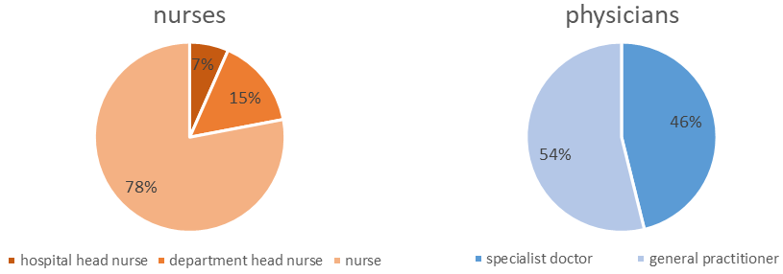
Fig. 1: Results by professional roles

4.4.1 Nurses’ answers
The results of the nurses’ responses are in Table 2. Some of the most salient results are:
- Lack of knowledge about the Local Emergency Plan from the local government (50%)
- Lack of knowledge about the number of beds and isolation units in all healthcare facilities in Albania (53%)
- No participation in exercises / drills in their current institution for rapid response to large-scale emergencies (50%)
- Basic confidence to perform ALS procedures (38%)
- Interest to be allowed and trained to perform, as part of their professional program:
  - Maneuvers for basic life support and operation of automatic external defibrillators (87%)
  - Administer oxygen (90%)
  - Initiation of peripheral venous infusion and fluids (84%)
  - Other (63%)
When asked an open question on training topics to prioritize, nurses from the emergency department requested continuous training in the following topics:
- Protocols and management during the following events:
  - accidents
  - coordination and cooperation with other medical teams, fire department, and police
  - emergencies, fires, and accidents
  - life-or-death emergency treatment
  - mass casualty emergencies
  - medical emergencies
  - natural disasters (fires, earthquake, floods)
  - patient evacuation and transport
  - pediatric emergencies
  - vigilance of infectious diseases and pandemics
- techniques and treatment:
  - ALS
  - basic emergency medications and administration
  - BLS
  - CPR
  - ECG reading
  - first aid in emergencies
  - first aid during ambulance transport
  - HTA and strokes
  - intensive care in the elderly with chronic diseases
  - nursing care
  - oxygen therapy
  - qualification and use of life-saving medical equipment
  - trauma/polytrauma
  - tracheal intubation
  - treatment of anaphylactic shocks, cardiac arrest, cardiopulmonary resuscitation, burns, intoxications, and hemorrhage
  - Triage
  - wound treatment: suturing and caring of wounds
- Nursing management
- Psychological support, panic, and PTSD handling for patients and their families
- Soft-skills:
  - doctor-nurse cooperation and teamwork
  - communication
- Knowledge of legislation, emergency management structures, and individual competences
- Implementation of regulations, ethics, privacy, and deontology
- Sensitizing the population to assist in the provision of first aid
- Use of the hospital insurance market tool
Some additional points were the systematization of the premises of the emergency department; evaluation of structural, non-structural, and functional components of hospitals, and regulation of conditions during emergencies.

4.4.2 Physicians’ answers
The results of the physicians’ responses are in Table 3. Some of the most relevant points are:
- Not familiar with procedures to receive psychological and mental health support in your organization (48%)
- Lack of knowledge about:
  - the Local Emergency Plan from the local government (63%)
  - emergency response plans and operational procedures for high casualty events and disasters (46%)
  - the number of beds and isolation units in all healthcare facilities in Albania (54%)
  - competencies and capacities of different specialized health care providers in emergency situations (41%)
  - capacities of other emergency services, like firefighters and volunteer first aid responders (51%)
- Lack of training in:
  - assessment, follow-up, and notification on potential public health threats (56%)
  - the latest guidelines and protocols for emergency healthcare (48%)
  - just-in-time programs for personal preparedness, protective equipment, demobilizing, and recovery (58%)
  - in ensuring adequate staff capacity and competency in areas with sudden potential increases in clinical demand, such as emergency and intensive care (50%)
- The last training in emergency medicine was more than 5 years ago (46%)
- No participation in exercises / drills in their current institution for:
  - rapid response to large-scale emergencies (71%)
  - cross-health care facility coordination, including primary care, municipal hospital, and regional hospitals in emergencies (59%)
  - providing feedback and extracting learnings from emergency response operations (55%)
  - high casualty events or disasters that require upscaling medical response, including personnel capacities (65%)
- Not qualified to perform ALS procedures (48%)
- Basic confidence to perform ALS procedures (38%) and trauma assessment and management (37%)
- Medium confidence to perform CPR and BLS (44%)
When asked an open question on training topics to prioritize, physicians from the emergency department requested continuous training in the following topics:
- Multidisciplinary cooperation and communication between field medical staff, operational, and emergency intervention (firefighters, police, NGOs, army, ARC, etc.) staff
- Protocols and management during the following events:
  - medical emergencies (triage, recording of injuries, immobilization, and transport to the health center)
  - diseases and epidemics
  - trauma
  - natural disasters (earthquakes, floods, fires etc.)
  - large-scale, mass incident events
  - automobile accidents
  - pre-hospital emergencies
  - field hospitals
  - rescue operations
- techniques and treatment:
  - Advanced Cardiovascular Life Support (ACLS)
  - ALS
  - Advanced Trauma Life Support (ATLS)
  - cardiopulmonary resuscitation
  - Pediatric Advanced Life Support (PALS)
  - poisoning
- Psychological and social support for patients (e.g., attempted suicides)
Additionally, they raised the topic on improving medical capacities by increasing the number of medical equipment for both the emergency department and ambulances, as well as guaranteeing enough staff at pre-hospital and hospital emergency services.

Gap analysis and ranking of competencies and training needs
Detailed analysis regarding factors associated with competencies and training needs in the field of emergency medical care and health emergency in the Albanian context. (ToR 3.7)

5.1 Gap analysis
The gap analysis serves to understand the difference between the current state of competencies and training of municipality hospitals, PHC facilities and emergency PHC facilities’ staff on emergency medical care and the desired state. We conducted the gap analysis of competencies and training needs based on the ECDC-based methodology proposed in Section 2.

5.1.1 Gap analysis of competencies
Capability | Capability indicators and competencies | Gap
1) Detection and assessment | Surveillance and epidemiological monitoring  - Establish and maintain indicator and event-based surveillance system(s) to detect public health threats.  - Establish and maintain electronic real-time reporting systems.  - Interpret information from existing surveillance in order to characterize affected population groups, and to monitor disease trends and the impact of control strategies. | - Lack of systemic structures to monitor antimicrobial resistance  - Communication of diagnostic results from diagnostic laboratories to medical staff during the pandemic’s beginning was done orally for individual results
2) Policy development, adaptation, and implementation | For infection control and treatment guidance  - Regularly assess and, as needed, clarify existing policies and/or recommend/advocate measures and communicate them to health officials at the ministry level, border control officials, and others.  - Share relevant information with healthcare, infection control, and patient transport experts, and solicit their feedback.  - Aid the transfer of medical and related professionals across borders and facilities through standardized job descriptions of personnel in clinical settings. | - No regular updates of procedures during the pandemic response  - No involvement of medical staff to improve training protocols for addressing infectious diseases and pandemics after the return to normality. To strengthen systemic resilience through continuous improvement, there needs to be involvement of the front-line staff in discussions to improve the response to EM surges  - Lack of standardized job descriptions- in terms of roles, responsibilities, and activities- for physicians and nurses in EM: As an example, we observed that, in certain facilities, physicians carried out the triage as nurses lacked the training. This duplication/overlap of activities or gap of capacities makes the system ineffective.
2) Policy development, adaptation, and implementation | Communicating between national and subnational authorities and enforcing laws and regulations  - Before response activities are taken, regularly review, test, and update the standard operating procedures and ensure that a multi-unit task force is available for the coordination and integration of relevant sectors during response operations. | - Missing action plans and Standard Operating Procedure (SOP) for Mass Casualty Events (MCE)  - Not enough knowledge of existing SOP for emergency medical surges and trauma patients
3) Health services | Medical surges  - Ensure that plans across the continuum of care have been communicated to the clinical staff to effectively manage surge needs.  - Plan for combining resources at national and local levels (e.g., cross-border sharing of clinicians if a hospital reaches capacity).  - Establish processes for staffing related surge issues including credentialing, paying staff, channels of authority, extended crisis interventions, and livelihood protection at home. | - No plan to re-distribute patients according to bed and healthcare availability: While COVID-hospitals were over their maximum capacity, beds were empty in other departments.  - Centralized pandemic response in Tirana: The COVID hospitals were opened in Tirana, which meant both nation-wide COVID patients needed to be brought to Tirana for treatment, and COVID hospitals in Tirana received patients beyond their capacity, putting additional stress and pressure on the medical staff with work overload.  - Lack of specialists in Infectious Diseases, and most of them are located in Tirana  - COVID patients isolated in the COVID ward were not able to get treatment from other medical specialties (chronic diseases, oncology, etc.)  - Lack of structures to finance and improve staffing during emergencies: During the pandemic, medical staff had work overload with medical units exceeding their capacity, while others were relatively empty. This problem was not unique to Albania, but it offers the opportunity to better prepare for the next emergency.
3) Health services | Management of medical countermeasures, supplies, and equipment  - Work with health personnel to identify the best medical countermeasures based on risk and threat; relay the results of these conversations.  - Ensure flexible policies and procurement strategies among Member States including how to allocate resources in the event of a shortage.  - Ensure there are adequate levels of human resources (e.g., experts) and laboratory capacity available in the Member States. | - Insufficient budget for the acquisition of medical equipment; for example, life-saving AEDs in PHC, hospitals, and ambulances  - Insufficient budget to create a telephone contact line (“green line”), in coordination with the Order of Psychologists, for people to receive psychological support: In the last emergencies, psychologists voluntarily gave their contact numbers.  - Lack of standardization in medical equipment and maintenance periodicity.  - Lack of incentives to specialize in Emergency Medicine: The conditions under which specialized physicians and nurses work, in terms of human resources and remuneration, are not strong: In the EM department, if a GP with basic training in EM from their PHC facility can do the same work and be paid the same as an EM specialist, there is no reason to make the specialization. As a direct consequence, there are not enough physicians specialized in EM in both hospitals and ambulance services. For this reason, nurses sometimes need to take over ambulance service, or physicians from other specialties take over the emergency ward while their EM colleague is away.
3) Health services | Medical services for healthcare workers and emergency responders  - Before a response operation, relay to healthcare workers the importance of their role in public health emergencies and support their personal preparedness and that of their families. | - Insufficient attention for psychological impact during emergencies for medical personnel themselves: Some potential reasons were the work overload and burnout itself of the medical personnel, which didn’t give them time to take care of themselves, a cultural negative perception of seeking psychological support, and therefore no pro-active provision or offer of specific mental health / psychological support to medical staff during emergencies  - No empowerment of nurses as central players in emergency medical response.
4) Coordination and communication (within the public health emergency preparedness system) | Crisis management  - Before the response operation, practice and test the ability to make decisions under uncertainty  - Participate in the implementation of plans which ensure the continuity of operations | - Implementation of existing emergency response plans is lagging: They're not regularly trained or refreshed  - Disruption of continuity of operation, especially for vulnerable groups: Chronic patients, patients requiring dialysis, and children with Thalassemia or leukemia either needed transport to Tirana to receive HC services or, due to logistics problems, needed to have their drugs, medication, or donated blood transported to their municipalities.
 | Crisis management  - Develop protocols and test/exercise processes for health emergency operations and their activation  Communication with emergency management, public safety, and other sectors  - Advocate the development of plans for joint task forces or other entities which can share information across disciplines. | - A very limited number of major, joint exercises with cross-sector key partners to foster preparedness and coordination during an emergency: Without joint drills, exercises, and simulations, this can compromise the operational response and coordination during emergencies. While each institution has its capacities, they requested the possibility to conduct MCE simulations with other institutes, such as FF, the police, and civil protection agencies.
5) Emergency risk communication (with the public) | Address communication inequalities  - Address cultural and societal barriers in the cognitive processing and compliance with recommended behaviors.  - Use the most appropriate content and trusted channels of communication across population groups.  - Identify strategies to overcome linguistic barriers, e.g., request local assistance. | - Still at an early stage of the implementation of MoHSP’s reform to include psychologists and social workers across the PHC facilities.
5) Emergency risk communication (with the public) | Use dynamic listening and manage rumors  - Identify data gathering mechanisms to understand and monitor the informational needs of the population.  - Proactively address the needs of the news media and the general public. | - An accurate civil registry and additional vulnerability data of the population are required for the development of emergency management plans that consider vulnerable groups (elderly, people living alone, children with Thalassemia or leukemia, abused women, and Romani groups). The ARC and civil organizations such as ACA are the most active, collaborating with local communities and vulnerable groups and empowering local leaders.
5) Emergency risk communication (with the public) | Communicate risk in an accurate, transparent, and timely manner  - Integrate the results of the risk-assessment process in the messages.  - Anticipate questions from the public and develop appropriate answers.  - Understand and implement the principles of risk communication. | - Need to improve communication and change the population’s behavior toward healthier lifestyles, and disease prevention through regular check-ups, blood donation, and vaccination campaigns.
5) Emergency risk communication (with the public) | Foster and maintain trust  - Provide information to the public on the roles and responsibilities of the various organizations involved in the response operation; try to understand the public’s perception of the emergency.  - Identify communication mechanisms that are trusted by the public, partners, and community influencers. | - Mistrust and misconception of service provision by family doctors in PHC: Because of this, people go directly to the ED in hospitals instead. There are only a limited number of programs that bring the PHC staff in contact with the community, to change the behavior on both sides and strengthen trust in family medicine specialists in PHC.

5.1.2 Gap analysis of training needs
Capability | Capability indicators and competencies | Gap
2) Policy development, adaptation, and implementation | Communicating between national and subnational authorities and enforcing laws and regulations  - Before response activities are taken, regularly review, test, and update the standard operating procedures and ensure that a multi-unit task force is available for the coordination and integration of relevant sectors during response operations.  - Before the response operation, ensure the adequacy of plans for financing and credentialing of staff during emergency situations. | - Absence of national protocols and guidelines for training in case of MCE.  - CME/CNE does not reflect the level of relevant professional competencies  - Beyond the EM specialty program for doctors, no relevant training standards have been set according to each medical field involved in Emergency Response.
3) Health services | Medical surges  - Prior to an event, work in tandem with clinicians to develop medical surge plans for various threats.  - Ensure that plans across the continuum of care have been communicated to the clinical staff to effectively manage surge needs.  - Plan for combining resources at national and local levels (e.g., cross-border sharing of clinicians if a hospital reaches capacity). | - Lack of a standardized and structured training plan for specialized and non-specialized medical staff in emergency medicine and medical surge response; training is usually requested on a case-to-case basis  - There is insufficient practical training and exercises in areas of increased clinical demand, including emergency and intensive care  - Limited medical education on emergency knowledge, practical skills, and bedside training among health care students  - The need for mobile training units to provide training in rural areas where there are small PHCs with limited staff that may not be able to leave the place for training.
3) Health services | Medical services for healthcare workers and emergency responders  - Use standardized approaches across Member States to engage with all personnel who may serve in field operations on the use of PPE.  - Before a response operation, relay to healthcare workers the importance of their role in public health emergencies and support their personal preparedness and that of their families.  - Plan for the demobilization and recovery of the healthcare workforce after a response operation. | - Not enough on-spot clinical training: This results in a gap between theoretical knowledge and practice, resulting in lack of skills to perform medical maneuvers and an inadequate level of competency.  - Nurses/doctors need to be trained in BLS + AED so they are allowed to use them while working in an ambulance and EDM; it needs to be a part of their job description and fixed in legislation.  - ICU specialists need to be trained in ALS/ ACLS according to the job description
4) Coordination and communication (within the public health emergency preparedness system) | Crisis management  - Develop protocols and test/exercise processes for health emergency operations and their activation  Communication with emergency management, public safety, and other sectors  - Advocate the development of plans for joint task forces or other entities which can share information across disciplines. | - Lack of combined training with other emergency responders (FF, PF, Volunteers, etc.). No standards for shared training.  - Insufficient number of national trainers and institutions offering EM training
 | Communication with healthcare providers  - Before the response operation, establish trust with healthcare providers through feedback loops and two-way communication. | - Top-down model for training decisions: There is no organized mechanism for evaluation and providing feedback on training, exercises, and drills.

5.2 Ranking of gaps
Ranking of the competencies and training needs identified through gap analysis was conducted with regard to their relevance and priority for the emergency medical care of the PHC and the municipality hospital. Ranking of gaps was carried out using the criteria described in Section 3.3, Data Analysis.

5.2.1 Highest-ranked competency gaps
- Lack of incentives to specialize in Emergency Medicine
- Not enough knowledge of existing SOP for emergency medical surges, while implementation is lagging
- A very limited number of major, joint exercises with cross-sector key partners to foster preparedness and coordination during an emergency
- Lack of standardized job descriptions- in terms of roles, responsibilities, and activities for physicians and nurses
- Insufficient attention to psychological impact during emergencies for medical personnel themselves
- No empowerment of nurses as central players in emergency medical response
- Insufficient budget for the acquisition of medical equipment; for example, life-saving AEDs in PHC, hospitals, and ambulances
- Gaps in populational data are required for the development of emergency management plans that consider vulnerable groups

5.2.2 Highest-ranked training needs gaps
- Due to the centralized system of training and certification of the medical/ nursing staff, there is an absence of knowledge assimilation. Until now the main training is performed by the National Center for Medical Emergencies.
- Because training is not mandatory, medical/nursing staff do not refresh and update their knowledge
- There are no training protocols and guidelines regarding training needs and priorities.
- There are not enough trainees, the existing ones cannot cover all training required in the health facilities.
- Due to the lack of trainers/ training programs/motivation/knowledge, there is an insufficient capability to perform BLS+AED in PHC.
- There is no mechanism for evaluating the training that is done and there is no mechanism for giving and receiving feedback
- There is an “abuse” of the CME/CNE system- it is used mainly for license renovation instead of training updates and promotion.
- The existing protocols need to be modified to fit the Albanian system.

Recommendations for competency and training building at PHC and municipal hospital level in Albania
Concrete recommendations for effective competency and training building approaches, models, and instruments in accordance with the existing structures, capacities and resources. (ToR 3.8)
The HAP project and the World Bank-funded “Ready 2 Respond” project identified training of health personnel as a key prerequisite for a functioning emergency system. Therefore, the following recommendations aim to strengthen the EM system in Albania by providing recommendations to improve competency, institutional capacities, and training offer.

6.1 Recommendations for building competency
Requirements of skills, competencies, and credits in emergency medicine in the context of the CME system and license renewal. (ToR 3.4)

Define response indicators as drivers for development of the PHC and response system.: Measurable performance indicators for local, regional and national medical command and control can be applied to incidents that directly or indirectly involve casualties provided there is sufficient documentation available. Measurable performance indicators can enhance follow- up and be used as a structured quality control tool as well as constitute measurable parts of a nationally based follow-up system for major incidents. Additional indicators need to be developed for hospital-related incidents such as interference with hospital infrastructure. Indicators will assist in defining the quantity and quality of required personnel (training) and their strategic distribution over the country to achieve measurable goals (response time to incident, time until on site pain treatment, time to deploy an AED anywhere in Albania).
Strengthen EM and emergency response in health care by making it part of CME and professional license renewal: Enhance the emergency knowledge among medical and nursing students, especially in the following topics: BLS, ALS, ACLS, and AED. With the collaboration of the MoHSP and Professional Orders, participation in relevant theoretical and practical courses can be made mandatory every two years and for the professional license renewal. Some of the courses could be combined with an online theoretical part and a relatively short time, and following the theatrical part, having practical simulation under trainees' supervision will be cost-effective and will be able to train a large number of teams. To guarantee the development of practical skills, PHC units and municipal hospitals need to establish a regular training program for all ED staff based on medical priorities (46% of physicians indicated in the online questionnaire that their last training in EM had taken place more than 5 years ago). Training doctors and nurses together is recommended to enhance teamwork collaboration.
Plan training and 5-year refreshers for Infectious Disease specialists in response to high-risk, high-impact emergencies and disasters: This includes response to pandemics, floods, earthquakes, and antimicrobial resistance, among others. Due to its periodicity, this program can be included as part of the CME and license renewal structure.
Clear description of skills and competencies on emergency medical care in regulatory documents, statutes, and job description of PHC facilities, emergency PHC facilities and municipality hospitals. (ToR 3.4)
Create defined job description and activities: The MoHSP, along with the Orders of Physicians and Nurses, need to create a clear description of nurse ‘job description and professional activities based on training, qualification, competency, authority, and field (hospitals, PHC, ED, and ambulances). Written descriptions drive the system for efficiency, allow the creation of defined training plans, and promotes specialization in EM. Roles and descriptions must:
1) Empower nurses through a clear definition of role, responsibility, and the authority given by the Nursing Order / MoHSP to perform actions and be protected by the law.
2) Promote teamwork and collaboration between physicians and nurses.
Improve legislation on nurses’ roles, authority, and performance: Special consideration goes to nurses undertaking their professional activities without doctors to empower and delegate authority to ambulance staff.
Improvement to the actual education and professional training of the staff working in the field of medical emergency. (ToR 3.4)
Extend the practical/clinical training time for doctors and nurses nationwide: Current practical, clinical education and bedside training are not enough. EM studies should have more hours in the curricula of both medical and nursing students; and clinical training time should be expanded in the EM specialist program.
Develop training programs according to the roles and competencies of health professionals: Once job and activity descriptions have been defined, training programs must be adapted to promote professional growth pathways. In the case of EM, the training program must cover large emergencies, use of PPE, surveillance, epidemiological investigation, and MCE response and management.
Improvement of curricula for the preparation of personnel working in medical emergencies and the standard package of ongoing education, in line with international standards. (ToR 3.4)
Define nurse’s practical training based on “Nursing Action” (ANNEX 3): There is a need to legislate the nurse’s work and to establish “Nursing Actions”–based on training, qualifications, competencies, and authorities provided by the state. The “Nursing Action” is an action that is anchored as a "nursing practice" action in public health regulations. It is allowed to be performed by any nurse according to her professional training; nurses are allowed to perform it wherever the treatment is required. The responsibility for the safe performance of these operations and updating the knowledge relevant to their performance falls on the qualified nurse. The performance of the processes is conditional upon a doctor's order and/or a signed protocol approved by the Operator / MoHSP. The definition of “Nursing Action” will help to provide efficient, professional treatment to the patients and provide better legal protection to the nurses, including protection from nursing malpractice.
Support to health practitioners (doctors and nurses) for performing and practicing emergency medical care. (ToR 3.4)
Create enabling structures and incentives for physicians with a specialization in EM: Since it is a newly introduced specialty, there is still a need to consolidate the figure of the EM specialist doctors within the ED. Currently, this role is covered by GP with additional training in EM; therefore, it is important to create the conditions that promote the specialization of physicians in the ED.
Guarantee enough staff at pre-hospital and hospital emergency services: The request to increase the capacity of PHC units and municipal hospitals came from physicians working in the ED through the online questionnaire. GP/Family Doctors working in the ambulatory are also currently required to cover night shifts in the ED, which puts additional strain on medical staff and decreases their capacity to respond to large-scale emergencies.
Create a psychological support platform for medical professionals: It is necessary to conduct a study regarding the level of burnout in healthcare providers in Albania. This will help to understand how many of the medical/nursing staff require mental support. It is important also, to take into consideration the cultural aspect of the staff when approaching this subject. Only then we could support the staff and help to avoid burnout. When a healthcare provider gets psychological support, it helps him/her to have a better performance at work and home.
Assign budget for the acquisition of medical equipment for PHC units, hospitals, and ambulances: EM physicians identified the need of acquiring medical equipment, such as life-saving AEDs, for use both in the EDs and ambulances.
Improvement of physical distribution and mapping of emergency medical care services, taking into consideration vulnerable populations in remote areas. (ToR 3.4, 3.5)
Create incentives and improve working conditions for EM and Infectious Disease specialists working in regional areas: This strategy aims to decentralize emergency response and treatments from Tirana or urban areas, therefore improving access to health care systems in remote areas or for vulnerable groups, avoiding a systemic overload in the country’s capital in case of an emergency, and strengthening local and regional response capabilities. As part of their training, sending regional physicians and nurses to get in touch directly with the community builds trust at the PHC level and changes both the medical and community’s behavior toward each other by building trust.

6.2 Recommendations for improving trainings
Through an all-inclusive dialogue within given top-down criteria, develop a model (equipment, administration and co-funding) for regional multipurpose training centers for multidisciplinary emergency preparedness & response under the civil protection agency considering the geographic accessibility.
Support NCPA/AKMC’s creation of a training center for competency building and joint training exercises: The NCPA/AKMC’s training center would work as a central organizational location and platform for joint exercises among several departments (FF, EMC, PF, and ARC, among others) at basic and advanced levels, at a national and regional level. This would enable development capacities in civil capacities, for example, in urban Search-and-Rescue (USAR). This will require the creation of a curriculum and the planning of regular courses and exercises. The development of this curriculum can be strengthened through the cooperation with other EU Partners as part of the EU Civil Protection Mechanism to improve prevention, preparedness, and response to disasters.
Plan and create a calendar for cross-sectional, joint training, drills, and exercises:
Taking into account the national regulatory framework for emergency health care response, the development of a shared vision on training and the use of common training center is advised. This vision is to be established in dialogue with all stakeholders in the EP&R sector, and should explicitly include a vision on emergency healthcare and on cost sharing and co-funding. To come to this vision an all stakeholder inclusive dialogue is required including strong representation of local actors on policy and operational level. This dialogue is advised to include instruments measuring opinions of the wider community and specifically persons with specific needs. The first challenge to overcome is to deliver clear top down framework as to the criteria and the expected outcome of this dialogue in order to facilitate constructive cooperation and to limit interagency competition during the inclusive dialogue. It is advised to start this dialogue on short term.
To establish a foundation for successful dialogue aim to establish workgroups and include the order of physicians, order of nurses, the operator, mental healthcare, health inspectorate, the ministry of health and the management of health care facilities on all levels and any other relevant stakeholders. To support commitment and enthusiasm, the working groups are to write at the start their interconnected terms of reference withing the criteria to be defined top-down. These criteria should also define what organization and well respected person is to be leading the dialogue in the direction of the best collective and broadly supported outcome for training and training facilities.
50% of nurses and 71% of physicians reported in the online questionnaire that they hadn’t participated in exercises or drills in their current institution for rapid response to large-scale emergencies; combined with limited knowledge on the emergency response capacity of other partner institutions, these values highlight the importance of promoting this type of exercises. These cross-sectional activities may include, but are not limited to, simulation of MCE, table-top exercises, joint drills, and meetings to discuss case studies and updated knowledge. These joint exercises should be planned and scheduled in collaboration between the AKMC, MoHSP, and heads of districts in advance. Every institution will be informed about the planned calendar and will have the time to prepare itself by having in-house training. The pre-planned training could be delivered, for example, at the AKMC Training Center. Alternatively, the training/simulation/ drill could be held at the relevant medical facility (HMC/ municipal /regional/ referral hospital. The planning of said exercises should provide an incentive and driver for the involved institutions to establish and improve the protocols required for their participation in the event.
Empower regional PHC systems to be able to build their own multi-unit emergency task force to prepare for a medical emergency: These units must include ambulance service and medical personnel, on stand-by and ready to respond at all times at a regional level. During regular times, these specialists can be capacitated to provide EM training and direct exercises, drills, and simulations. Once regional multi-unit emergency task forces have been set, municipal ones can be created in a second stage.
Propose curricula for ToT for professional and non-professional figures, including a database model for training programs. (ToR 3.5)
Create Training of Trainers (ToT) in EM: Since there are not enough trainees, and the existing ones cannot cover all health facilities To increase autonomy in emergency capacities in Albania, we propose the ToT model. The goal is to create a network of local trainers, assisted at the beginning by foreign trainers, which can prepare other professionals either in urban or remote areas and strengthen both the autonomy and increased offer of Albanian EM education. The figure of specialized trainers in EM must offer nurses and physicians an attractive professional development pathway. These leading experts can act as trainers during regular times in sensibilization, exercises, and drills while providing “Just in Case” training that prepares the staff to identify potential threats and to provide “Just in Time training” when an emergency occurs and there is a need for knowledge update. This, in addition to coordinating the emergency medical response during an emergency. This also makes Albanian CME training offer more sustainability: Open competition leads to better quality and prices of the courses offered.
Create a database model with online training offer and programs in EM: The MoHSP, University of Medicine, Hospital and PHC units and emergency departments, and AKMC’s Department in Continuous Education can collaborate to develop a centralized platform with online training programs. This theoretical program will be supplemented with a practical component for skills development. The two main advantages of the online platform are: it doesn’t require medical personnel to commute to a training center- especially for staff working in remote rural areas-, and pre-recorded material with defined deadlines provides time flexibility. The online curriculum would be available online, for example, as a platform under the QKEV. Open participation of different stakeholders to create and upload material to a central platform will facilitate access, overview, and an increased offer of diverse training programs for healthcare personnel, while also improving the quality of content through the democratization and competition in content creation and offer.
Develop a concept note for knowledge building interventions within the national framework for emergencies and emergency health care, with the aim of preserving lives and protecting health and potentially social wellbeing. (ToR 3.5)
Change the behavior towards “training”: Practical training must be mandatory and part of the curriculum: The use of CME/CNE for renewing the license resulted in a defeat of the initial purpose of the use: To enhance knowledge and skills as part of continuous education during the career. In light of the above, it is recommended to assure that CME/CNE meet the need to renew the license and at the same time adapt to the professional specialization and practical training needs that will be determined as mandatory and refresh periodically as part of the CME/CNE. To achieve this, it is necessary to establish training protocols and guidelines based on EU protocols, with adaptation to the health system and the EM unique to Albania.
Establish a mechanism for training assessment, giving and receiving feedback: This applies for both trainers and trainees from medical and non-medical staff (social workers, psychologists, first aiders, and volunteers) on training, exercises, and drills. The assessment will help to update and modify the theoretical and practical training, drills, and exercises as requested by the EU standards. At the same time, it will promote the empowerment and participation of the different stakeholders as part of continuous improvement and lead to an equal standard of care across the country.
Create campaigns to inform and train ED personnel in local emergency plans: Both ED physicians (63%) and nurses (50%) noted in the online questionnaire a lack of knowledge of local emergency plans from the local government. Therefore, campaigns and drills with the local (municipal) governments need to be created to improve knowledge and the ability to coordinate and respond in case of an emergency.
Training needs of the staff working in the field of medical emergency (e.g., developed by Red Cross). (ToR 3.5)
Training topic priorities for ED medical personnel: Based on the results of the questionnaire, physicians and nurses working in the ED expressed their interest for practical training, drills, and exercises in the following subjects:
- Both physicians and nurses:
  - Joint drills for coordination and cooperation with medical and non-medical staff (firefighters, police, NGOs, army, ARC) for large-scale emergencies
  - Knowledge and practical training on protocols and management during medical emergencies (triage, recording and treatment of injuries, immobilization, and transport to the health center), infectious diseases and pandemics, trauma, natural disasters (earthquakes, floods, and fires), large-scale MCE, automobile accidents, pre-hospital emergencies, field hospitals, and rescue operations
  - Practical training in ALS, ACLS, ALS, ATLS, CPR, PALS, and treatment of anaphylactic shocks, cardiac arrest, strokes, burns, intoxications, hemorrhage, and poisoning
  - Psychological support for panic, attempted suicide, and PTSD handling for patients and their families
- Physicians:
  - Assessment, follow-up, and notification on potential public health threats
  - Management skills in areas with sudden potential increases in clinical demand, such as emergency and intensive care, and just-in-time programs for personal preparedness, protective equipment, demobilizing, and recovery
- Nurses:
  - Knowledge and practical training on patient evacuation and transport, basic emergency medication and administration, ECG readings, first aid during ambulance support, and intensive care in the elderly with chronic diseases
  - Knowledge of legislation, emergency management structures, and individual competences
  - Development of soft-skills for doctor-nurse cooperation and teamwork and improved communication
  - Skills in nursing management
  - Request to include 1) BLS maneuvers and AED operation, 2) oxygen administration, and 3) initiation of peripheral venous infusion and fluids as part of their professional activities to be qualified and trained to perform them
Deliver BLS + AED training: Based on the information gathered (a combination of lack of trainers, training programs, and knowledge), there is an insufficient capability to perform BLS+AED in PHC; 38% of nurses and physicians in the online questionnaire reported only basic confidence to provide ALS, with 44% of physicians expressing medium confidence to perform CPR and BLS. Therefore, it is recommended to deliver the BLS+AED training as soon as possible. Nurses/doctors need to be trained in BLS + AED so they are allowed to use them while working in an ambulance and ED and it will be part of their job description, fixed in legislation. ICU specialists need to be trained in ALS/ ACLS according to the job description.
Propose small-scale exercise drill plans and models for (small) communities in emergencies. (ToR 3.5)
Design training and small-scale exercise drills for medical staff in remote areas: The training can be provided using existing hubs that are already involved in health education (HAP and NCCE/QKEV), local civil society organization’s representatives, and ARC local volunteer leaders to promote community engagement and design small-scale exercise drills and plans that will be sustainable. It is also suggested to develop a module on health to be incorporated into initiatives in emergency activities and to focus on municipality hospitals, primary healthcare, and the use of mobile units.
Propose a clear list of professional and non-professional figures involved in emergency response and emergency health care and develop a concept for training and knowledge building (ToR 3.5).
Create clinical instructors to supervise nurses’ clinical training: It is highly recommended to designate a particular department’s nurse to become a clinical instructor. The clinical instructor should be trained and qualified to teach and guide the nursing students. Furthermore, it will be his/her responsibility to ensure that the student fulfills the training program, and she will be the coordinator for the program on behalf of the University’s Faculty of Technical Medical Sciences. This requires the cooperation and involvement of the faculty with the department.
Support the creation of a specialized field of competence in Emergency Psychology: By supporting training from international experts, the Order of Psychologists can establish this new discipline in Albania to respond more efficiently in emergencies, improve the capabilities of psychologists involved, and create its educated workforce to train other trainers to create specialists. There is a need for this specialty to support teams involved with emergency response and to keep team resilience, as well as patients and other populations that may develop Acute Stress Reactions following emergencies.
Propose models/best practices of enhancing community engagement and propose programs for local level volunteers and emergency responders. (ToR 3.5)
Involve the general public in first responder actions: The goal is to get the general public involved in public education in all areas of CPR+BLS, both in high schools and other universities’ faculties. It should be considered with the Ministry of Education to encourage high school students to join the training and refresh their knowledge by providing them with credential points as part of the matriculation exam. The PHC system can create communication channels and drills, together with the civil population, on how to respond to a medical surge or emergency, especially in schools, hospitals, and high-density urban areas.
Work on communication strategies to promote visits to the GP/ Family Doctors: This strategy aims for people to visit the GP/ Family Doctor and, unless necessary, to not go directly to the ED in hospitals. This will relieve the ED personnel and allow them to focus on emergencies. Miscommunication on waiting times and family doctors’ capabilities must be addressed, potentially through collaboration with social workers and local community leaders.
Evaluate together with relevant actors the involvement of private businesses in emergency preparedness. (ToR 3.5)

Promote the MoHSP’s project to digitize the medical system to strengthen online systems and user competency for information exchange among PHC centers: This will facilitate the communication of diagnostic results and improve communication between either the laboratories and medical staff or across health care facilities. In case of an emergency, this will also facilitate the transfer of patients across institutes or departments and the identification of bed availability across departments and isolation units, while avoiding confusion and/or duplication of efforts to keep printed medical profiles at both sites. The private sector can be engaged to promote the digitization of medical services.

Literature
Areas of expertise and attainment targets for Emergency nursing care (The Netherlands).
CENA practice standards for the Emergency Nursing Specialist 2013 (Australia).
CSTE (2017). 2017 Epidemiology Capacity Assessment Report.
ECDC (2017). A literature review of Training Needs Assessment (TRNA) methodology.
ECDC (2017). Public health emergency preparedness core competencies for EU Member States.
EUSEN. http://eusen.org/?page_id=1192
ICN Nursing care continuum framework and competencies.
Learning outcomes for a bachelor in Emergency care; presentation of Maria Deneire 2014 (Belgium)
Ministry of Health and Social Protection (2021a). Albanian National Health Strategy, 2021-2030.
Ministry of Health and Social Protection (2021b). Strategy on the development of primary health care services in Albania, 2020-2025.
NENA standards and practice Emergency core competencies 2014 (Canada).
QKUM (2017). Framework legislation Nr. 147/2014, date 30.10.2014, “On Medical Emergency Service”.
Republic of Albania (2022). National Disaster Risk Reduction Strategy 2023-2030.
WHO Regional Office for Europe (2012). Toolkit for assessing health-system capacity for crisis management.
WHO Regional Office for Europe (2011). Hospital emergency response checklist.
WHO Western Pacific Region (2007). Field manual for the capacity assessment of health facilities in responding to emergencies.
UNDP (2010). Measuring Capacity.
World Bank (2021). Ready2Respond Diagnostic Report: Emergency Preparedness and Response Assessment, Albania.

ANNEX 1: Table of interviewees

Name | Role | Institution
Andi Koraqi | Head of Clinical Microbiology | Mother Teresa University Hospital Center
Besim Nuri | Project Manager & HAP Center Executive Director | Health for All Project (HAP)
Blerina Duka | President | Order of Nurses of Albania
Blerta Ndrekaj | Health Coordinator & Blood Donation | Red Cross Albania
Denada Lacej | Medical Microbiologist | Mother Teresa University Hospital Center
Denisa Canameti | Program Manager | Together for Life (TfL)
Dritan Karkini | Head nurse | Kavajë Municipal Hospital (Spitali Kavajë)
Eda Brahimaj | Head of Safety and Health at Work | State Inspectorate of Labor and Social Services (ISHPSHS)
Edmond Puca | MD, Infectious Diseases | Mother Teresa University Hospital Center
Edmond Zaimi | Lecturer in Emergency Medicine | University of Medicine, Tirana
Eglantina Bardhi | Executive Director | Together! For Life! (TfL)
Ehadu Mersini | HAP Center Deputy Director and Quality of Care Specialist | Health for All Project (HAP)
Elona Mustafaraj | General Secretary | Order of Psychologists of Albania
Eqerem Hasani | Head of Emergency Department | Mother Teresa University Hospital Center

Erisa Cara | Vice-director | Kavaja Municipal Hospital (Spitali Kavajë)
Fatmir Brahimaj | President | Order of Physicians of Albania
Fatos Xhengo | Disaster Management Coordinator | Red Cross Albania
Holta Koci | Executive Director | Albanian Community Assist (ACA)
Ilirjana Zekja | Dean of the Faculty of Technical Medical Sciences | University of Medicine, Tirana
Jetmira Deda | Head Nurse | Kamez Health Center (Qendra Shëndetësore Kamëz)
Klajdi Nikolla | Director of International Cooperation and Projects | National Civil Protection Agency (AKMC)
Lulejet Hidi | First Aid Service Coordinator | Red Cross Albania
Luneda Sufali | Director | State Health Inspectorate of Albania (ISHSH)
Mariana Bukli | Health & Nutrition Specialist | United Nations International Children's Emergency Fund (UNICEF)
Mimoza Vogli | Economic Director | Kavaja Municipal Hospital (Spitali Kavajë)
Miranda Horieti | Director for Primary Healthcare Centers | The operator of Healthcare, Region of Tirana
Mirush Dema | Economic Director | Kamez Health Center (Qendra Shëndetësore Kamëz)

Najada Como | Vice Dean | University of Medicine, Tirana, Faculty of Medicine
Shkendije Gruda | Director | Vora Health Center (Qendra Shëndetësore Vorë)
Sonila Peza | Director | Kavaja Municipal Hospital (Spitali Kavajë)
Suida Kuka | General Director | The operator of Healthcare, Region of Tirana
Zhenihen Zanaj | National Health Programme Officer | Embassy of Switzerland in Albania

ANNEX 2: Online Questionnaire
For a Swiss government-funded project, an assessment is carried out to inform future training projects that aim to improve the preparedness and performance of the Albanian healthcare system during disasters and emergencies. As a frontline healthcare provider, your input in this survey is very important for Albania!
type of facility | primary health care facility municipal hospital  regional hospital  university hospital
department | emergency department  other departments
location | City  countryside
professional function | general practitioner  specialist doctor  hospital chief nurse  department head nurse  staff nurse  hospital director  department director
age | <=30  30-50  >=50  prefer not to answer
gender | male  female  prefer not to answer
1) Are you familiar with procedures to:
survey and report a suspected health emergency? | Yes No Not applicable to me
control infectious diseases or epidemics outbreaks at your place of work? | Yes No Not applicable to me
document pathogens, likely sources, and transmission pathways to control an outbreak? | Yes No Not applicable to me
to mobilize resources and personnel during events and disasters with many victims (loss of life)? | Yes No Not applicable to me
evacuate patients in large-scale casualty events and disasters? | Yes No Not applicable to me
report shortage of beds? | Yes No Not applicable to me
receive psychological and mental health support in your organization? | Yes No Not applicable to me
2) Are you knowledgeable about:
emergency management and incident management systems in Albania? | Yes No Not applicable to me
the Local Emergency Plan from the local government? | Yes No Not applicable to me
emergency plans in your health care facility? | Yes No Not applicable to me
emergency response plans and operational procedures for high casualty events and disasters? | Yes No Not applicable to me
basic principles of infection control and treatment? | Yes No Not applicable to me
microbiological characteristics of pathogens with a pandemic potential? | Yes No Not applicable to me
containment plans for high-impact infectious diseases? | Yes No Not applicable to me
risk of rising antimicrobial resistance and the need for mitigation? | Yes No Not applicable to me
needs created by medical growth? | Yes No Not applicable to me
the number of beds and isolation units in your health care facility? | Yes No Not applicable to me
the number of beds and isolation units in all health institutions in Albania? | Yes No Not applicable to me
competencies and capacities of different specialized health care providers in emergencies? | Yes No Not applicable to me
capacities of other emergency services, like firefighters and volunteer first aid responders? | Yes No Not applicable to me
3) Have you received training in:
assessment, follow-up, and notification on potential public health threats? | Yes No Not applicable to me
safety measures, medical countermeasures, vaccines, and risk mitigation? | Yes No Not applicable to me
the latest guidelines and protocols for emergency healthcare? | Yes No Not applicable to me
just-in-time programs for personal preparedness, protective equipment, demobilizing, and recovery? | Yes No Not applicable to me
registration and dealing with an increased number of patients during disease outbreaks? | Yes No Not applicable to me
ensuring adequate staff capacity and competency in areas with sudden potential increases in clinical demand, such as emergency and intensive care. | Yes No Not applicable to me
cultural awareness, sensitivity, and skills, to meet the needs of patients with different cultural backgrounds? | Yes No Not applicable to me
4) When did you receive your last training in:
emergency medicine? | 0-2 years  3-5 years  >5 years
5) Have you participated in exercises/drills in your current institution for:
rapid response to large-scale emergencies? | Yes No Not applicable to me
cross-healthcare facility coordination, including primary care, municipal hospital, and regional hospitals in emergencies? | Yes No Not applicable to me
providing feedback and extracting learnings from emergency response operations? | Yes No Not applicable to me
high casualty events or disasters that require an upscaling medical response, including personnel capacities? | Yes No Not applicable to me
6) Have you been qualified to perform:
Triage and initial assessment of patients? | Yes No Not applicable to me
Cardiopulmonary resuscitation (CPR) and first aid (BLS - basic life-saving procedures)? | Yes No Not applicable to me
Advanced life support (ALS) procedures? | Yes No Not applicable to me
Emergency medication administration? | Yes No Not applicable to me
Trauma assessment and management? | Yes No Not applicable to me
Communication and teamwork in emergencies? | Yes No Not applicable to me
Psychological support for patients and families in crisis? | Yes No Not applicable to me
7) On a scale of 1 (basic) to 3 (proficient), how confident are you to perform the following activities?
Triage and initial assessment of patients | 1 2 3
Cardiopulmonary resuscitation (CPR) and first aid (BLS - basic life-saving procedures) | 1 2 3
Advanced life support (ALS) procedures | 1 2 3
Administration of emergency medications | 1 2 3
Trauma assessment and management | 1 2 3
Communication and teamwork in emergencies | 1 2 3
Psychological support for patients and families in crisis | 1 2 3
8) Which training topics should be prioritized to build a stronger response system for large-scale casualty events and disasters in Albania?
1
2
3
9) (For nurses only) If you were allowed and trained to perform it, what kind of practical skills would you like to include in your training program?
Maneuvers for basic life support and operation of automatic external defibrillators | Yes No Not applicable to me
Administer oxygen | Yes No Not applicable to me
Initiation of peripheral venous infusion and fluids | Yes No Not applicable to me
Other: (please specify) | Yes No Not applicable to me

ANNEX 3: EuSEN Emergency Department Nurse Competencies
Competence is an ability with a theoretical basis that can be practically assessed. An individual who achieves competence must have a defined level of theoretical knowledge and the ability to demonstrate a practical application of those skills in a wide range of clinical scenarios including:
1. Clinical skills
2. Communication skills
3. Teamwork/collaboration
4. Knowledge and scope of practice
5. Professional development
6. Organizational awareness
7. Research
8. Quality improvement
1. Clinical skills
- Early detection of critical presenting symptoms.
- Assessment of patients based on the Airway, Breathing, Circulation, Disability, and Exposure (ABCDE) methodology.
- Initiation of timely nursing interventions following evidence-based clinical pathways and guidelines.
- Continuous assessment and early escalation of care based on clinical knowledge to minimize the risk of deterioration.
- Application of critical thinking skills to recognize and actively participate in the treatment of a wide range of clinical presentations.
- Utilization of Triage as a dynamic process to ensure continuous prioritization of patients based on clinical needs.
- Application of the triage process to ensure that the patient is seen at the right time, in the right place by the right caregiver for the right reason.
2. Communication
- Communicates effectively and professionally with patients, relatives, and the multidisciplinary clinical team
- Utilization of available technologies to maximize communication and support patients’ independence and autonomy.
- Communicates with all members of the multi-disciplinary team prioritizing a patient-centered approach.
- Communicates professionally.
- Delivers clear, concise, accurate, and timely communication.
3. Teamwork/collaboration
- Coordination and participation within the multidisciplinary team to respond to the patient’s needs based on clinical urgency.
- Recognition and response to all emergency and disaster situations.
- Appropriate initiation of referrals to multi-disciplinary team members or service providers outside the Emergency Department to support individualized patient care.
4. Knowledge and scope of practice
- Application of emergency nursing care within individual professional scope of practice and seeking support or guidance as appropriate.
- Actively seeks feedback from colleagues whilst critically reflecting on personal and professional nursing practice.
5. Professional development
- Has achieved or is working towards a postgraduate qualification in Emergency Nursing.
- Maintains a professional portfolio that includes documented learning and performance goals.
- Participates and contributes to activities or events that enhance the profile of emergency nursing.
6. Organizational awareness
- Functions as a professional representative of the Emergency Department.
- Manages space within the Emergency Department to achieve maximum efficiency and optimize patient flow.
- Proactively manages patient flow to minimize the impact of access blocks and to optimize patient safety.
- Actively maintains and supports professional networks both inside and outside their healthcare organization.
- Demonstrates a thorough working knowledge of departmental and organizational policies and procedures.
7. Research
- Participates in and supports research that promotes emergency nursing.
- Promotes a culture of research and evidence-based practice within the emergency nursing care profession.
8. Quality improvement
- Takes personal responsibility for professional development.
- Actively contributes to the development of professional standards in Emergency Nursing.
- Promotes and participates in a culture of continuous quality improvement within the emergency nursing profession.
*Nursing interventions
A/B: Assessment of airways and breathing. Administration of oxygen, nasal, oral, or inhalation medications (nursing standing orders).
C: Assessment of circulation, intravenous (IV) cannula insertion, administration of IV medications, and completion of an Electrocardiograph (ECG).
D: Collection of the patient’s vital signs, blood sugar level (BSL), and Glasgow Coma Scale (GCS).
E: Completion of a full body check (head to toe), clinical assessment, and application of casts or wound dressings.
Others:
Collection of blood or urine samples, insertion of a urinary catheter, and ordering of limb X-rays as appropriate.

ANNEX 4: Figures of questionnaire’s results

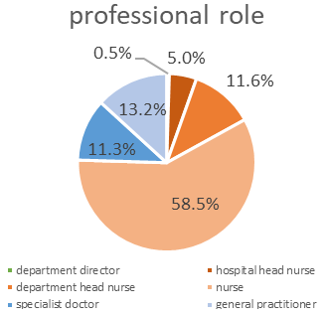
Fig. 2. Participants in the questionnaire according to their professional role

Table 4. Nurses’ response to questionnaire
Are you familiar with procedures to: | Yes | No | Not applicable for me
survey and report a suspected health emergency? | 78% | 15% | 7%
control infectious diseases or epidemics outbreaks at your place of work? | 75% | 17% | 8%
document pathogens, likely sources and transmission pathways to control an outbreak? | 67% | 21% | 12%
mobilize resources and personnel during high casualty events and disasters? | 74% | 16% | 10%
evacuate patients in large-scale casualty events and disasters? | 70% | 17% | 13%
report shortage of beds? | 45% | 32% | 23%
receive psychological and mental health support in your organization? | 50% | 44% | 7%
Are you knowledgeable about: | Yes | No | Not applicable for me
emergency management and incident management systems in Albania? | 69% | 24% | 7%
the Local Emergency Plan from the local government? | 42% | 50% | 8%
emergency plans in your health care facility? | 81% | 16% | 3%
emergency response plans and operational procedures for high casualty events and disasters? | 54% | 35% | 11%
basic principles of infection control and treatment? | 92% | 4% | 4%
microbiological characteristics of pathogens with a pandemic potential? | 63% | 29% | 8%
containment plans for high impact infectious diseases? | 69% | 22% | 8%
risk of rising antimicrobial resistance and need for mitigation? | 64% | 27% | 8%
needs created by medical surges? | 69% | 23% | 8%
the number of beds and isolation units in your health care facility? | 49% | 31% | 19%
the number of beds and isolation units in all healthcare facilities in Albania? | 28% | 53% | 20%
competencies and capacities of different specialized health care providers in emergency situations? | 53% | 36% | 11%
capacities of other emergency services, like firefighters and volunteer first aid responders? | 55% | 34% | 12%
Have you received training in: | Yes | No | Not applicable for me
assessment, follow-up and notification on potential public health threats? | 66% | 33% | 1%
safety measures, medical countermeasures, vaccines and risk mitigation? | 83% | 14% | 3%
the latest guidelines and protocols for emergency healthcare? | 66% | 32% | 3%
just-in-time programs for personal preparedness, protective equipment, demobilizing, and recovery? | 63% | 33% | 4%
registration and dealing with an increased number of patients during disease outbreaks? | 65% | 28% | 7%
ensuring adequate staff capacity and competency in areas with sudden potential increases in clinical demand, such as emergency and intensive care? | 58% | 33% | 9%
cultural awareness, sensitivity and skills, to meet the needs of patients with different cultural backgrounds? | 74% | 21% | 5%
When did you receive your last training in: | 0-2 years | 3-5 years | >5 years
emergency medicine? | 70% | 14% | 16%
Have you participated in exercises / drills in your current institution for: | Yes | No | Not applicable for me
rapid response to large-scale emergencies? | 47% | 50% | 3%
cross-health care facility coordination, including primary care, municipal hospital and regional hospitals in emergencies? | 60% | 36% | 4%
providing feedback and extracting learnings from emergency response operations? | 54% | 40% | 6%
high casualty events or disasters that require upscaling medical response, including personnel capacities? | 46% | 44% | 11%
Have you been qualified to perform: | Yes | No | Not applicable for me
Triage and initial assessment of patients | 83% | 13% | 3%
Cardiopulmonary resuscitation (CPR) and basic life support (BLS) | 78% | 15% | 7%
Advanced life support (ALS) procedures | 58% | 32% | 10%
Emergency medication administration | 92% | 5% | 2%
Trauma assessment and management | 75% | 17% | 8%
Communication and teamwork in emergency situations | 90% | 9% | 1%
Psychological support for patients and families in crisis | 89% | 10% | 0%
In a scale of 1 (basic) to 3 (proficient), how confident are you to perform the following activities? | 1 | 2 | 3
Triage and initial assessment of patients | 23% | 36% | 40%
Cardiopulmonary resuscitation (CPR) and basic life support (BLS) | 30% | 34% | 36%
Advanced life support (ALS) procedures | 38% | 30% | 32%
Emergency medication administration | 18% | 21% | 61%
Trauma assessment and management | 26% | 34% | 39%
Communication and teamwork in emergency situations | 18% | 18% | 64%
Psychological support for patients and families in crisis | 17% | 16% | 67%
If you were allowed and trained to perform it, what kind of practical skills would you like to include in your training program? | Yes | No | Not applicable for me
Maneuvers for basic life support and operation of automatic external defibrillators | 87% | 5% | 7%
Administer oxygen | 90% | 7% | 2%
Initiation of peripheral venous infusion and fluids | 84% | 12% | 2%
Other | 63% | 21% | 8%
Fig. 3. Nurses’ answers:
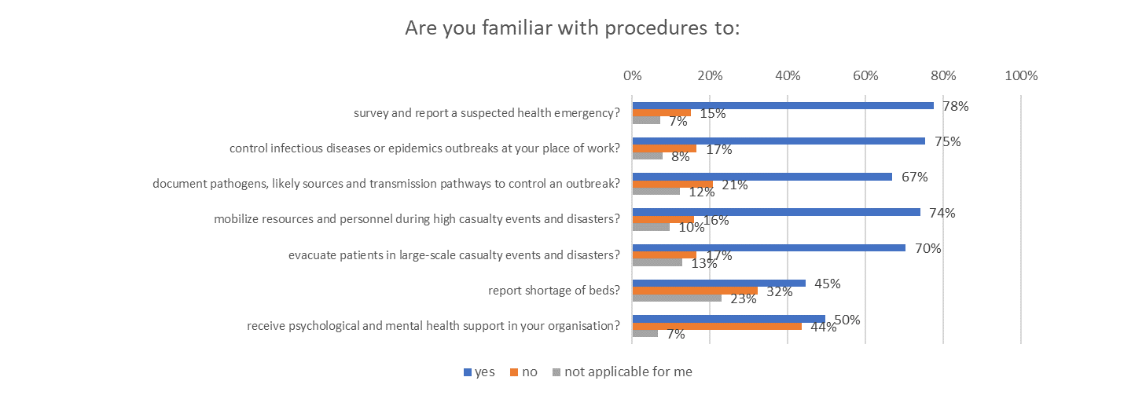
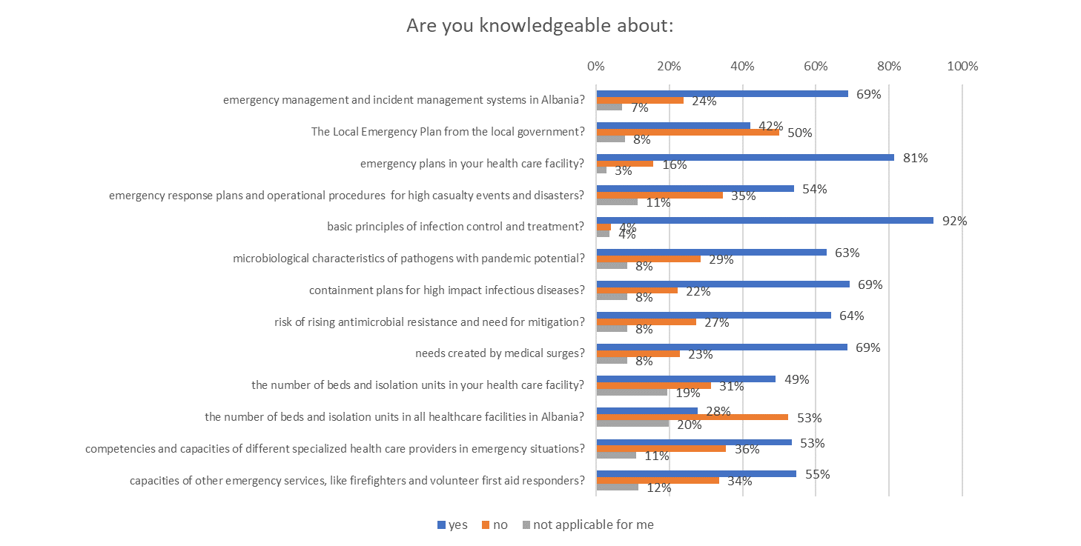
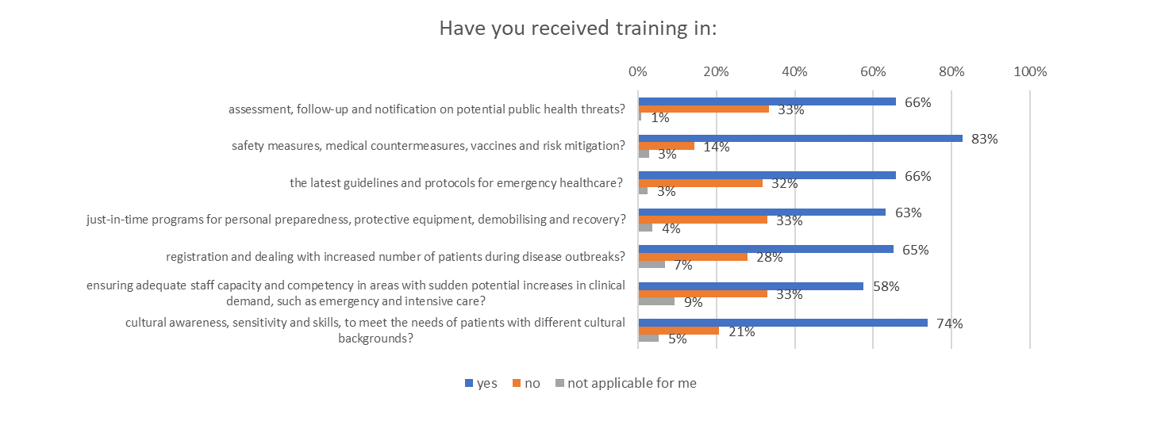
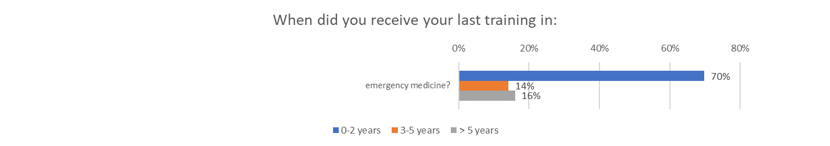
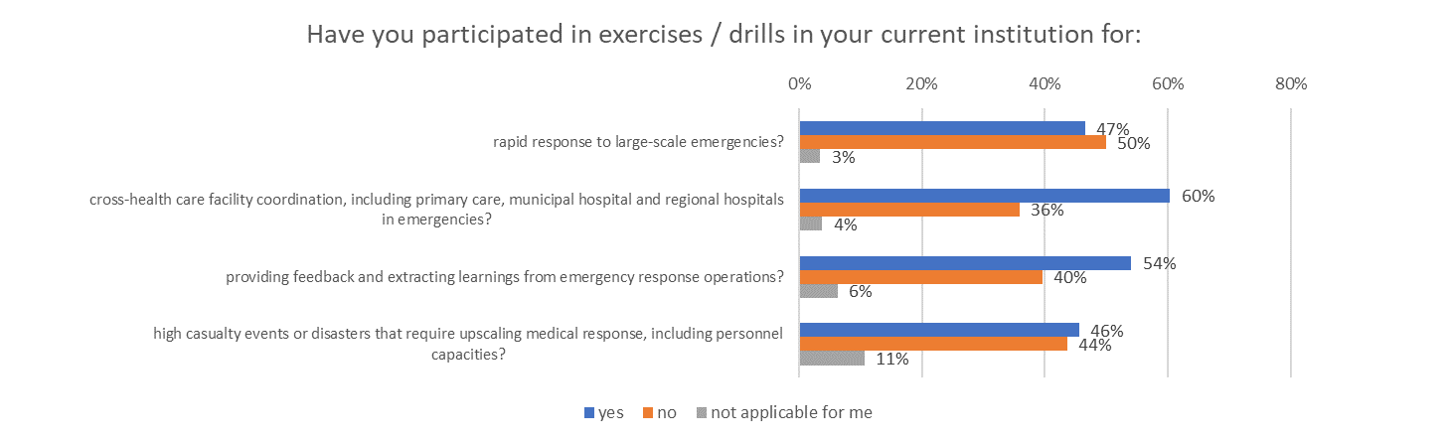
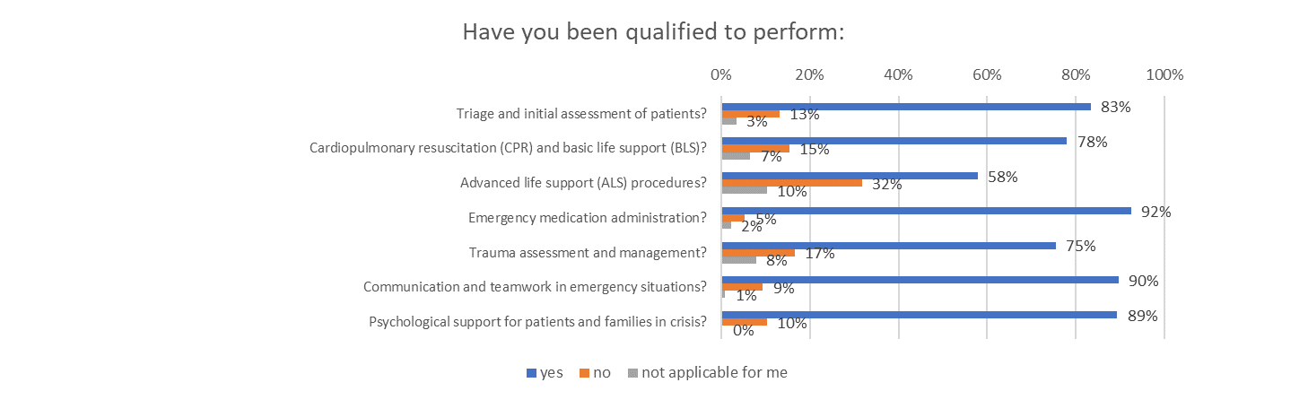
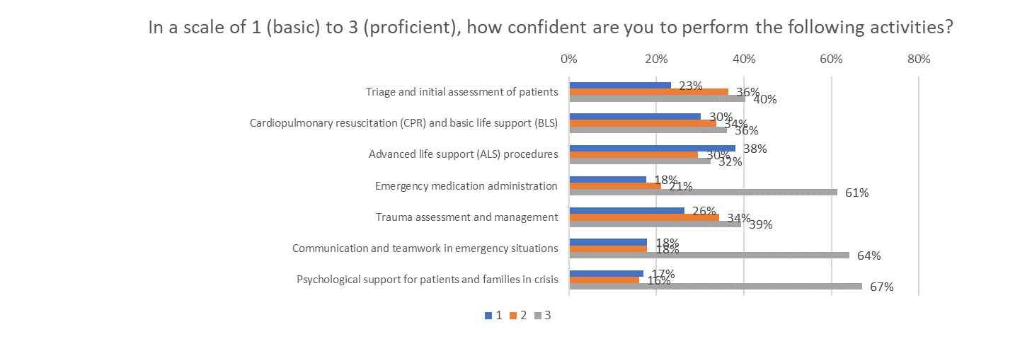
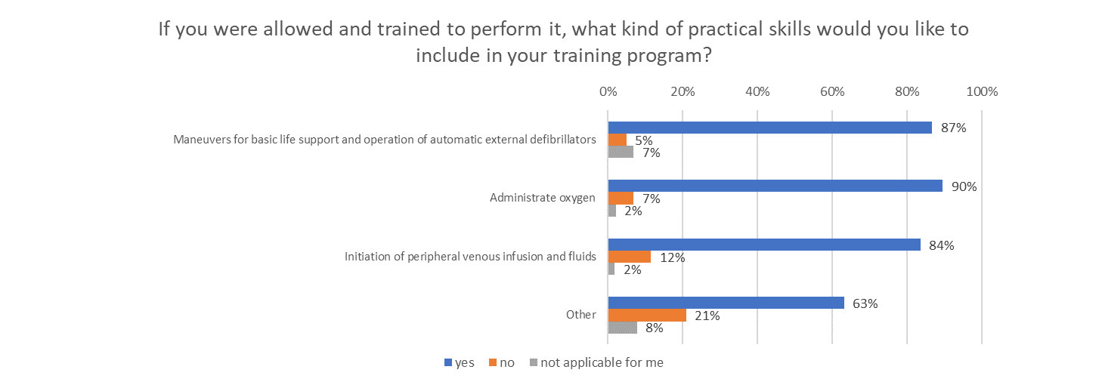

Table 4. Physicians’ response to questionnaire
Are you familiar with procedures to: | Yes | No | Not applicable for me
survey and report a suspected health emergency? | 74% | 17% | 9%
control infectious diseases or epidemics outbreaks at your place of work? | 76% | 15% | 9%
document pathogens, likely sources and transmission pathways to control an outbreak? | 59% | 24% | 17%
mobilize resources and personnel during high casualty events and disasters? | 66% | 17% | 16%
evacuate patients in large-scale casualty events and disasters? | 54% | 23% | 23%
report shortage of beds? | 33% | 29% | 38%
receive psychological and mental health support in your organization? | 40% | 48% | 12%
Are you knowledgeable about: | Yes | No | Not applicable for me
emergency management and incident management systems in Albania? | 59% | 35% | 7%
the Local Emergency Plan from the local government? | 26% | 63% | 11%
emergency plans in your health care facility? | 61% | 33% | 7%
emergency response plans and operational procedures for high casualty events and disasters? | 40% | 46% | 13%
basic principles of infection control and treatment? | 92% | 6% | 2%
microbiological characteristics of pathogens with a pandemic potential? | 66% | 21% | 13%
containment plans for high impact infectious diseases? | 61% | 32% | 8%
risk of rising antimicrobial resistance and need for mitigation? | 79% | 16% | 5%
needs created by medical surges? | 61% | 29% | 11%
the number of beds and isolation units in your health care facility? | 44% | 20% | 36%
the number of beds and isolation units in all healthcare facilities in Albania? | 13% | 54% | 33%
competencies and capacities of different specialized health care providers in emergency situations? | 38% | 41% | 21%
capacities of other emergency services, like firefighters and volunteer first aid responders? | 28% | 51% | 21%
Have you received training in: | Yes | No | Not applicable for me
assessment, follow-up and notification on potential public health threats? | 42% | 56% | 2%
safety measures, medical countermeasures, vaccines and risk mitigation? | 65% | 31% | 4%
the latest guidelines and protocols for emergency healthcare? | 44% | 48% | 8%
just-in-time programs for personal preparedness, protective equipment, demobilizing, and recovery? | 34% | 58% | 9%
registration and dealing with an increased number of patients during disease outbreaks? | 49% | 44% | 7%
ensuring adequate staff capacity and competency in areas with sudden potential increases in clinical demand, such as emergency and intensive care? | 31% | 50% | 19%
cultural awareness, sensitivity and skills, to meet the needs of patients with different cultural backgrounds? | 47% | 41% | 12%
When did you receive your last training in: | 0-2 years | 3-5 years | >5 years
emergency medicine? | 38% | 16% | 46%
Have you participated in exercises / drills in your current institution for: | Yes | No | Not applicable for me
rapid response to large-scale emergencies? | 20% | 71% | 9%
cross-health care facility coordination, including primary care, municipal hospital and regional hospitals in emergencies? | 34% | 59% | 8%
providing feedback and extracting learnings from emergency response operations? | 34% | 55% | 12%
high casualty events or disasters that require upscaling medical response, including personnel capacities? | 21% | 65% | 13%
Have you been qualified to perform: | Yes | No | Not applicable for me
Triage and initial assessment of patients | 78% | 13% | 9%
Cardiopulmonary resuscitation (CPR) and basic life support (BLS) | 80% | 16% | 4%
Advanced life support (ALS) procedures | 44% | 48% | 8%
Emergency medication administration | 79% | 18% | 3%
Trauma assessment and management | 60% | 32% | 9%
Communication and teamwork in emergency situations | 70% | 25% | 5%
Psychological support for patients and families in crisis | 64% | 29% | 7%
In a scale of 1 (basic) to 3 (proficient), how confident are you to perform the following activities? | 1 | 2 | 3
Triage and initial assessment of patients | 16% | 33% | 51%
Cardiopulmonary resuscitation (CPR) and basic life support (BLS) | 19% | 44% | 37%
Advanced life support (ALS) procedures | 49% | 33% | 18%
Emergency medication administration | 26% | 26% | 48%
Trauma assessment and management | 37% | 33% | 31%
Communication and teamwork in emergency situations | 25% | 26% | 49%
Psychological support for patients and families in crisis | 25% | 31% | 44%

Fig. 4. Physicians’ answers:
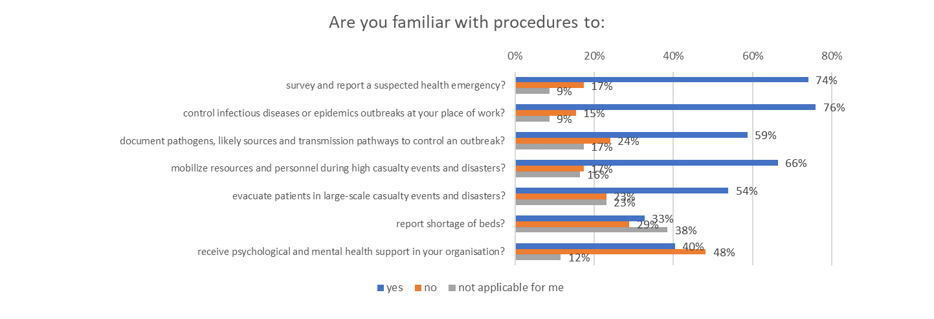
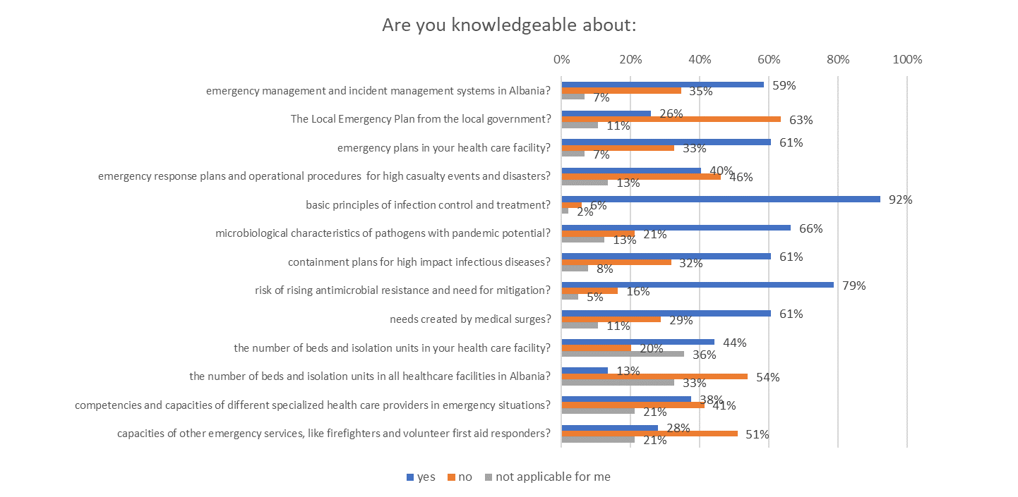
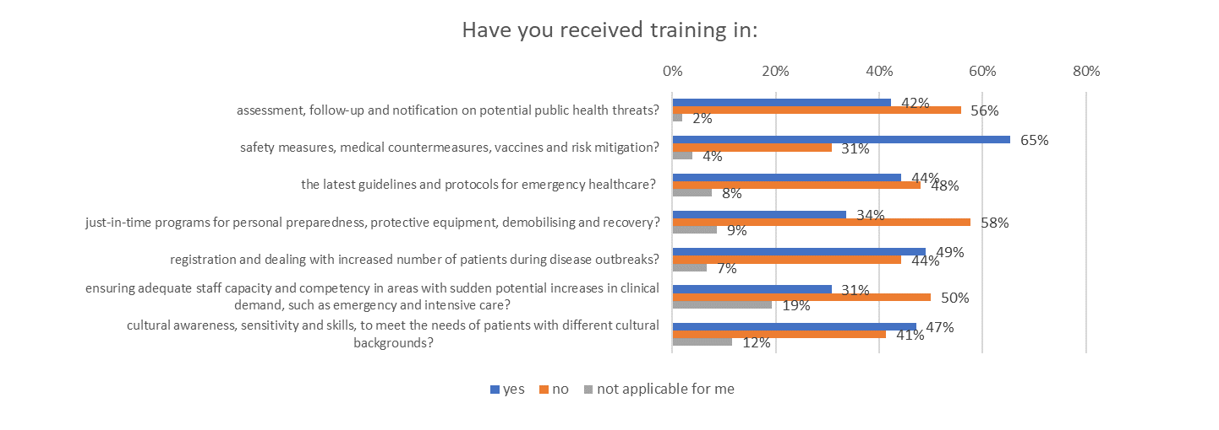
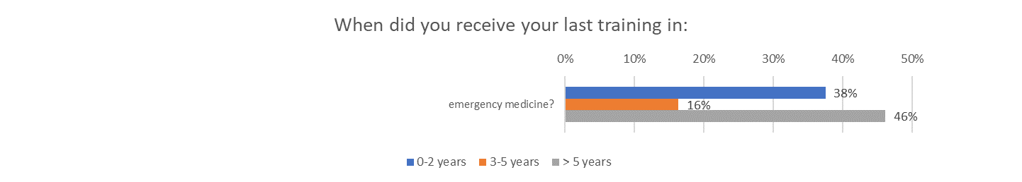
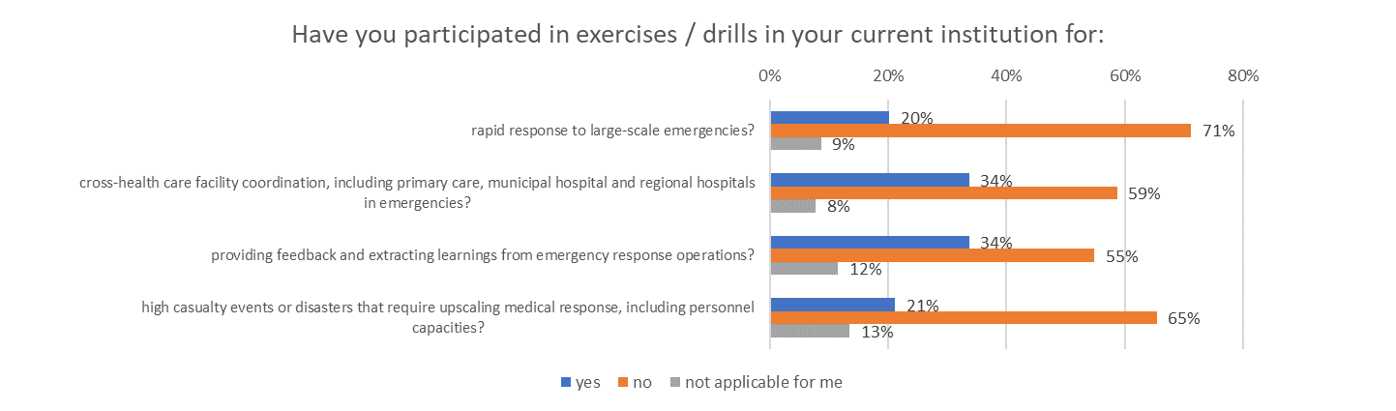
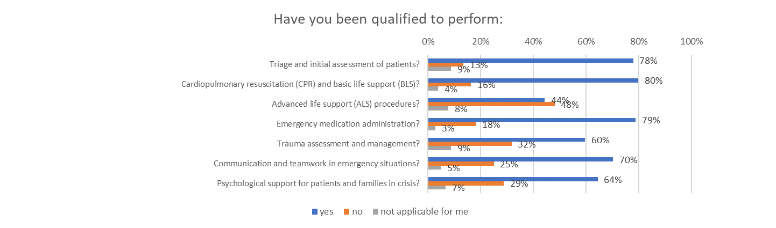
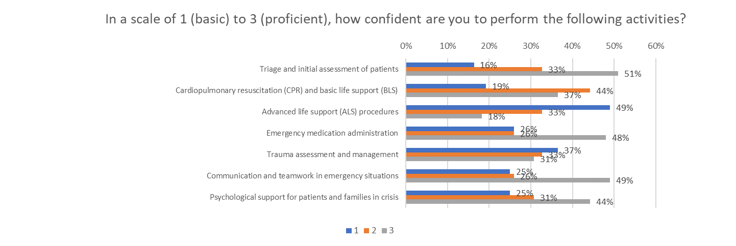





Prepared International (PPI) UG
Obereck 14, 83122 Samerberg, Bavaria – Germany
office@prepared-international.org www.prepared-international.org

Based on NIVEL 2015. Ambulance care in Europe. Organization and practices of ambulance services in 14 European countries. http://www.nivel.nl
NIVEL 2015. Ambulance care in Europe. Organization and practices of ambulance services in 14 European countries. http://www.nivel.nl
The Committee for National Hospital Planning, 2022

